Dromore Road Primary School

‘Together We Can’


First Aid Policy
Date Ratified:
Date of Review:

Contents

Page 3 Policy Statement and Introduction
Page 4 Statement of First Aid Provision
Page 5 Arrangements for First Aid
Page 7 First Aid Procedures
Page 10 Mental Health First Aider

Appendices

App. 1 EA online reporting form
App. 2 Head Bump note
App. 3 Department of Education Concussion Guidance
App. 4 AED Guidance from EA
App. 5 AED Guidance from EA (flowchart)

Policy Statement

The Principal and Board of Governors of Dromore Road Primary School accept their responsibility under the Health and Safety (First Aid) Regulations (Northern Ireland) 1982 and acknowledge the importance of providing First Aid for employees, children and visitors within the school.

The staff of Dromore Road Primary School recognise their statutory duty to comply with the Reporting of Injuries, Diseases and Dangerous Occurrences Regulations (Northern Ireland) 1997 and agree to abide by the EA procedure for reporting accidents.

This policy is closely linked with the Intimate Care Policy, Administration of Medicines Policy and Child Protection Policy and should be upheld in conjunction with them.

Introduction

First Aid is defined as the ‘help given to a sick or injured person until full medical treatment is available.’ (First Aid made East, 12th Edition)
Staff administering First Aid should seek to assess the situation, protect themselves and the casualty from further danger, deal with any life threatening condition and where necessary obtain medical assistance or refer the casualty to hospital as quickly as possible.

The purpose of First Aid is to:

- Preserve life
- Prevent the situation from worsening
- Promote recovery

Statement of First Aid Provision

The School’s arrangements for providing First Aid will:

- Place a duty on the Principal and Board of Governors to approve,
implement and review the First Aid policy
- Place individual duties on all employees
- Record when First Aid is administered to employees, pupils and
visitors in an Accident Book
- Report and record relevant accidents to EA using appropriate reporting form (See Appendix 1)
- Provide equipment and materials to enable staff to provide First Aid treatment
- Make arrangements with EA to provide First Aid training
for nominated members of staff, maintain records of training and
review every 3 years
- Establish a procedure for managing accidents in school which
require First Aid treatment (Appendix 1)
- Provide information to employees on the arrangements for First
Aid
- Use the information from the risk assessment of First Aid to
determine the number and level of trained staff and also any
additional requirements (eg specialised training for children with
particular medical needs)
- Notify parent/guardian that first aid treatment was given to the
child.

Arrangements for First Aid

First Aiders must ensure that:

- They familiarise themselves with current guidance and follow these requirements where it is possible to do so
- They undertake first aid duties applying the principles of social distancing (when appropriate) and infection control as much as is possible
- If necessary, where close contact is required, they follow the requirements for wearing and disposing of PPE, specifically paying attention to the sequence for PPE removal in order to avoid self-contamination (https://www.eani.org.uk/services/eatv/principal-videos/how-to-don-ppe https://www.eani.org.uk/services/eatv/principal-videos/ppe-training-introduction ) Donning PPE Order: 1. Apron 2. Mask 3. Eye protection 4. Gloves. Removing / Doffing PPE Order: 1. Gloves 2. Apron 3. Eye protection 4. Mask 5. Wash hands
- Ensure that the equipment is ready for use as part of their response arrangements.

The School will provide materials, equipment and facilities to administer First Aid. The location of the First Aid Kits in the School are:

- Staff room – 2 kits, one for school and one travel first aid kit
- One basic first aid kit in each classroom
- Playground at break and lunch – travel first aid kit
- Inhalers – one kept in child’s school bag and an emergency inhaler kept in staff room
- Auto injector – If a child is required to have an auto injector it should be stored in an agreed location and all staff should be made aware of this.

It is advised that the First Aid Kit should contain:

- conforming bandage
2 triangular bandage
1 burn dressing
- sterile eye pad
- finger dressings
- large sterile dressings
- sterile medium dressings
1 foil blanket
6 pairs of gloves
Guidance leaflet
40 plasters
1 Resuscitation face shield
1 Scissors
1 Microporous tape
20 Alcohol free wipes

The contents of the Kits will be checked on a regular basis by Mrs K. Graham and Mrs E Bedzeti and restocked as necessary.

The School First Aiders are Mrs K. Graham, Mrs E. Bedzeti and Mrs S McGrath. In the event that trained First Aiders are not available Mrs Boyd will take on the role of Appointed Person. In workplace First Aid, an Appointed Person is someone responsible for managing First Aid arrangements and calling emergencies services, but who doesn’t necessarily need to be a trained First Aider.

A portable First Aid kit will be taken on educational visits and is available in the staff room. Staff should check the contents of the kit before leaving on their trip.

Before undertaking any off site activities the level of first aid provision will be assessed by the Principal, as part of the risk assessment procedures, and at least one First Aid Kit will be taken along.

The Principal will inform all employees at the school of the following:

• The arrangements for recording and reporting of accidents
• The arrangements for First Aid
• Those employees who are qualified First Aiders
• The location of the First Aid Kits.

In addition the Principal will ensure that signs are displayed throughout the School providing the names of employees with First Aid qualifications. Each teacher will make their First Aid Kit available to all adults working in their classroom.

All members of staff will be made aware of the School’s First Aid policy. No member of staff should attempt to give First Aid unless they have been trained but minor cuts and grazes can be treated in the playground.

First aid Procedures

For their own protection and that of the injured person, staff who deliver First Aid should strive to wear disposable gloves. Where this cannot happen hands should be washed before and after administering First Aid using warm, soapy water.

Dealing with First Aid incidents
- Report to class teacher or classroom assistant for initial examination
- Clean wound with sterile dressing/apply cold compress
- In School First Aid accident Form will be completed
- In case of Head Bump, contact parent/carer and inform them of the need to monitor child and send home a Head Bump information note with the child. If the parent cannot be reached a First Aid and Bump note will be sent home with the child (See Appendix 2).
- Transfer child to care of First Aider if deemed necessary or if unsure.

In the case of a more serious injury the following additional steps should be taken:

- Contact a First Aider who will make an assessment of the situation and administer immediate first aid as appropriate
- School office should be informed of the situation and actions that are being taken and an ambulance to be called if required. Parents will be informed and asked to collect their child if ambulance not required
- NO child to be left unattended
- All serious incidents should be reported to the Principal
- If appropriate the EA Accident form completed by the Principal
- If it is impossible to reach the parents (or the emergency contact) and a hospital visit is deemed necessary then the following additional steps should be taken:
-An insured driver and First Aider should take the child to A&E.
-The school office should be kept informed and should continue
to try and make contact with the parents

- If the situation is LIFE THREATENING then an ambulance should be called at the earliest opportunity, without waiting for the appointed First Aider to arrive on the scene.

Additional actions when anaphylaxis occurs
In the case of a child/adult suffering anaphylaxis due to a known allergy the following steps should be taken:
- Call 999
- Assist casualty to administer their own auto injector
- If the causality is unable to administer auto-injector a trained adult may administer the device.

Accidents involving bumps to a Pupil’s head

The consequence of an injury from an accident involving a bump or blow to a pupil’s head is not always evident immediately and the effects may only become noticeable after a period of time.

Any bump to the head will be reported to parents via a phone call or first aid note sent home with the child. Every effort will be made to contact the parents via phone when the incident occurs.

Transport to hospital or home

The Principal will determine the appropriate action to be taken in each case. Where the injury requires urgent medical attention an ambulance will be called and the pupil’s parent or guardian will be notified. If hospital treatment is required, then the pupil’s parent/guardian will be called for them to take over responsibility. If no contact can be made with parent/guardian or other designated emergency contacts then the Principal may decide to transport the pupil to the hospital.

Where the Principal makes arrangements for transporting a child then the following points will be adhered to:

• Only staff cars insured to cover such transportation will be used
• No individual member of staff will be alone with the pupil in a vehicle; a second member of staff will monitor the child in transit.

School trips

When a school trip involves leaving the school grounds a teacher must take a First Aid Kit. Any children requiring personal medication should have it taken on the trip e.g. inhalers, auto-injector; children should be aware who is carrying their medication.

During swimming lessons a qualified lifeguard is available at all times and children are reminded of swimming pool rules.

Specific medical needs

Parents are requested to provide updated medical advice annually. It is important that all medical needs are passed on in a timely manner.
A register of any children with specific medical needs is held on SIMS and updated each year with staff being made aware.

Asthma
Parents of children who have been diagnosed with asthma are asked to bring an inhaler into school to be kept in the staff room. Pupil can also carry a personal inhaler in their school bag.

Allergies
Any children with an auto-injector will be made known to all staff and the location of their device will be clear to the child and staff.
Parents are asked to inform the school of all known allergies at the beginning of each school year. Dietary requirements are passed on to the school canteen when parents have completed the EA Special Diet Application form. If a medically prescribed diet is required the Special Diet Medical form should be completed and returned to school.

Use of the Defibrillator

Should the situation arise where there is an unconscious casualty who is not breathing the defibrillator should be brought from the school office and an ambulance called immediately.

Mental Health First Aid

We have two Mental Health First Aiders on the staff: Mrs K Graham and Mrs S McGrath.

Mental Health First Aiders Role:

- Help employees through a mental health first aid crisis (such as panic attacks or suicidal ideation)
- Identify someone that may be dealing with mental health issues, engage in contact and conversation effectively and plan a safe direction of action alongside the person of concern; until professional treatment is received or until the issue is resolved
- Engage with an individual suffering with a mental health issue or illness and in need of assistance
- Upholding employees’ confidentiality.

Responsibilities As a Mental Health First Aider

Mental Health First Aiders can have a profound and positive impact on the workplace. Carrying out your role responsibly involves the following:

- Keeping yourself safe and well – ensuring self-care and request additional support or advice if needed
- Communicating any concerns about the mental health and wellbeing of anyone in your workplace, for example to an appropriate manager
- Upholding your role as a Mental Health First Aider alongside your other responsibilities
- Establishing appropriate boundaries between yourself and colleagues you may be supporting.

This policy will be monitored and reviewed every three years unless a major incident or change in legislation requires an earlier review.

Signed: Principal Date

First Aiders Date

Date

Chairperson Date
Appendix 1 : Screenshot of EA online reporting form
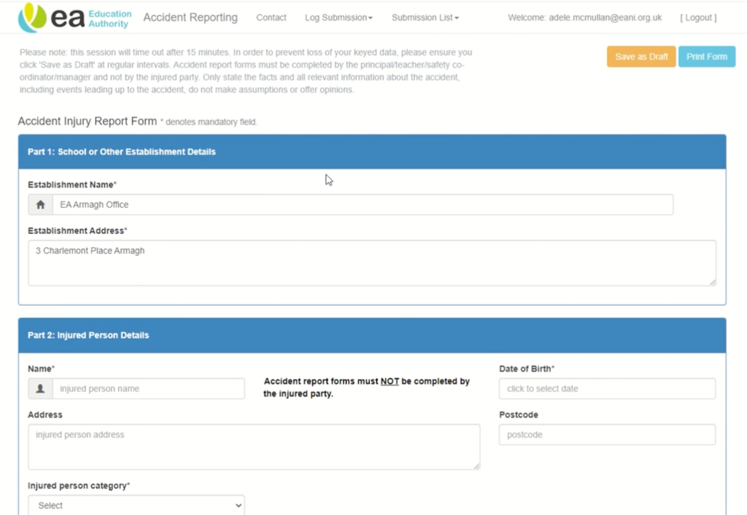

Appendix 2: Head bump note
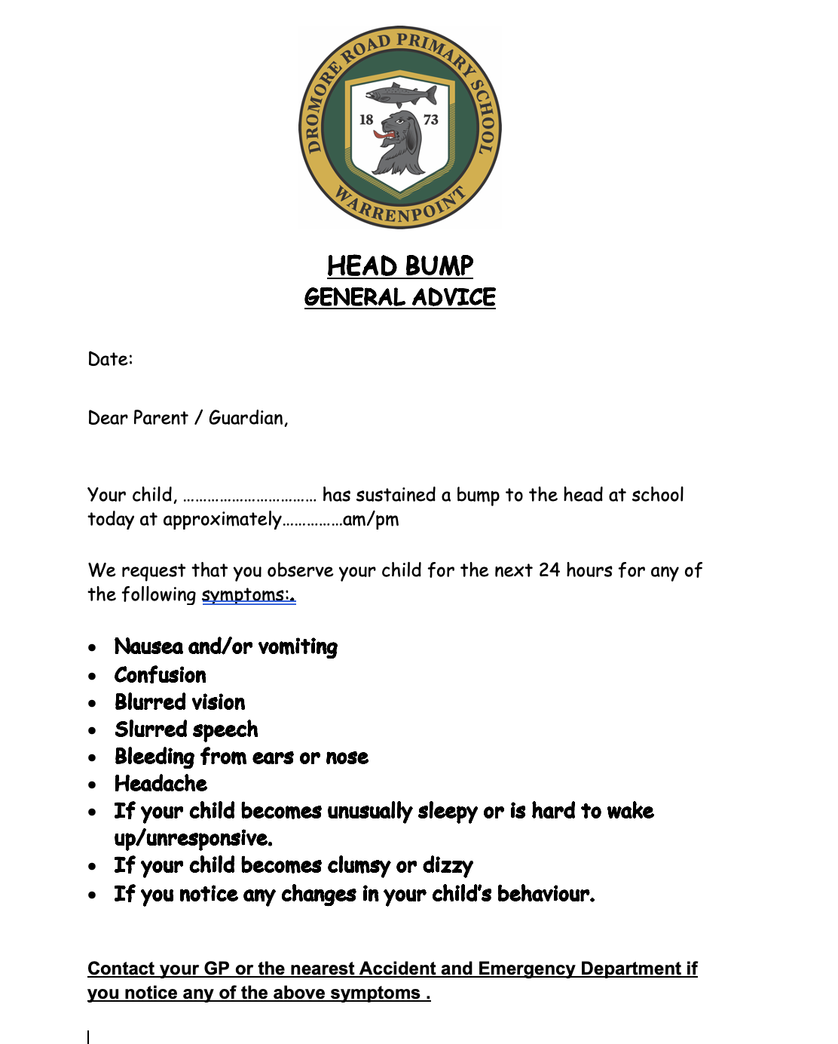

Appendix 3: Department of Education Concussion Guidance

https://www.education-ni.gov.uk/sites/default/files/publications/de/concussion-recognise-and-remove-leaflet.pdf

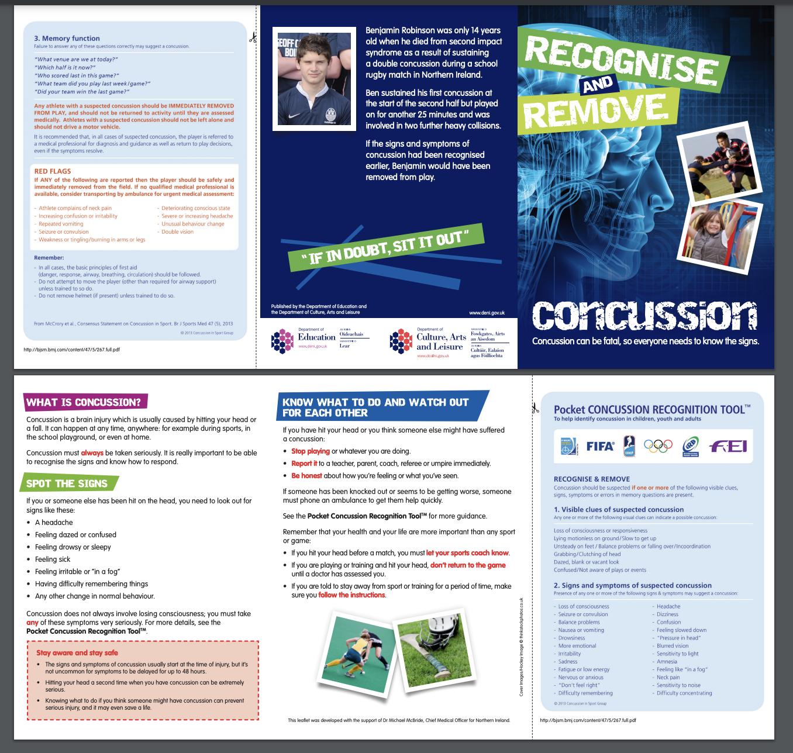

Appendix 4: AED Guidance from EA

https://www.eani.org.uk/sites/default/files/2018-10/AED%20Guidelines %20for%20Schools.pdf
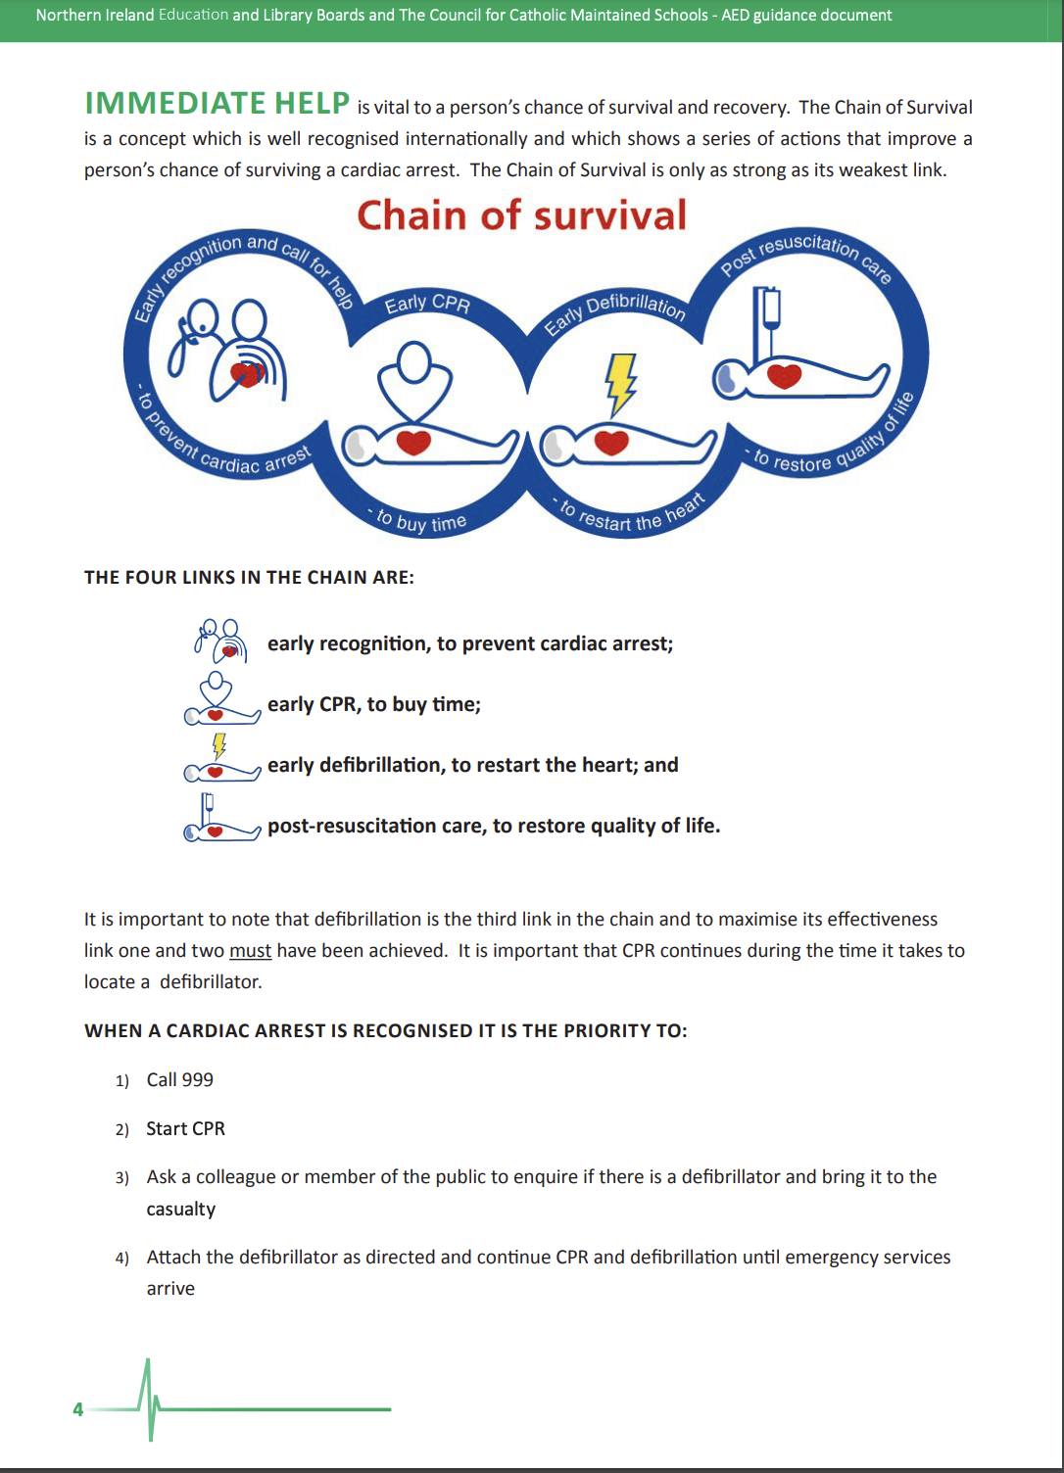
Appendix 5: AED Guidance from EA

