Dromore Road Primary School

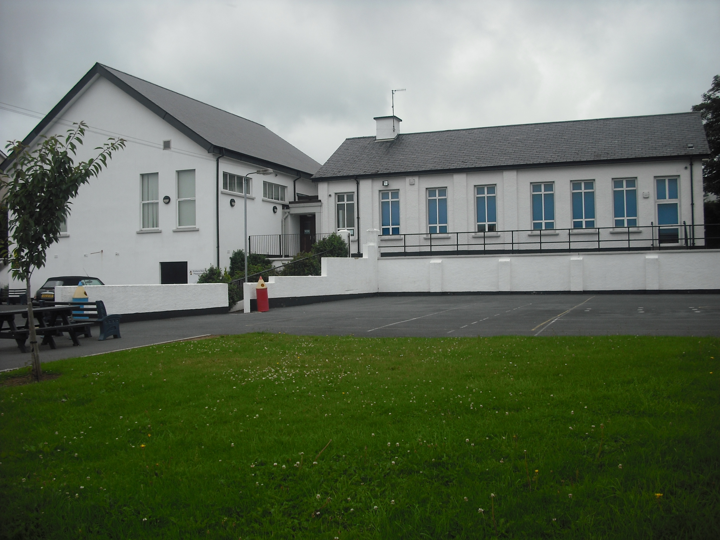
Dromore Road is a small controlled Primary school situated in the town of Warrenpoint. We provide a broad and balanced education for children from P1 – P7.

.

Marking and Feedback Policy


INTRODUCTION
This policy forms part of a whole school approach to teaching and learning. It relates to the ethos of the school and has direct links with curriculum planning and assessment.

At Dromore Road Primary School, we endeavour to provide a secure and happy atmosphere in which children can learn effectively. In doing so, we aim to use marking and feedback to enhance learning and to help all children achieve their highest possible level of competence.

How children’s work is received and marked and the nature of the feedback given to them will have a direct bearing on learning attitudes and therefore future achievements. At Dromore Road, we believe feedback and marking should contribute to children’s motivation as learners and as a result our marking and feedback methods are geared towards providing constructive feedback to every child. Making explicit to pupils how they have achieved success and indicating improvement needs against the specific learning intentions is central to shaping and directing learning. This effective practice will enable children to become reflective learners and help them to close the gap between current and desired performance.

The policy will be:

- consistently applied by all staff
- clear in its purpose
- manageable
- productive in its outcomes
- informed by pupils’ individual learning needs and previous assessments

Reasons for marking
The purposes of marking are:
- To recognise, encourage and reward children’s effort and achievement, and celebrate success.
- To provide a dialogue between teacher and children and clear appropriate feedback about strengths and weaknesses in their work.
- To improve a child’s confidence in reviewing their own work and whenever possible setting future targets, by indicating the next steps in learning.
- To indicate how a piece of work could be corrected or improved against assessment criteria.
- To help pupils develop an awareness of the standards they need to reach in order to achieve particular levels of the Revised Northern Ireland Curriculum.
- To identify pupils who need additional support/more challenging work and to identify the nature of the support/challenges needed.
- To provide evidence of assessments made and help moderate the interpretation of learning intentions and levels achieved.
- To involve parents more directly in reviewing their child’s progress and to help in reporting to parents.
- To aid curriculum planning.

Marking should be positive, clear and appropriate in its purpose – it needs to offer positive benefits to staff and children and the outcomes need to be fed back into planning.

Principles Underpinning Feedback

Marking and feedback should:
- Be manageable for teachers;
- Relate to learning intentions, which need to be shared with pupils;
- Involve the teachers and classroom assistants working with pupils in the classroom;
- Give children opportunities to become aware of and reflect on their learning needs;
- Give recognition and appropriate praise for achievement;
- Give clear strategies for improvement;
- Allow specific time for children to read, reflect and respond to marking;
- Involve pupils in the same process (whether oral or written), to ensure equity across subjects and abilities;
- Take a positive approach (linked to a person’s previous attainment or proposed potential) within the context of marking towards the learning intention;
- Respond to an individual learning need, marking face-to-face with some and at a distance for others;
- Inform future planning and individual target setting;
- Be accessible to children;
- Use consistent codes throughout the school;
- Ultimately be seen as positive in improving their learning;
- Encourage and teach children to self-mark wherever possible.

Strategies

At Dromore Road we recognise it is essential that children have some feedback about their work, but flexibility is important, depending on the nature of the task and the time available. In ensuring the marking and feedback process is both manageable for teachers and constructive for pupils, a range of strategies will be employed (see Appendix 1 for codes. These will be at an age appropriate level).

As immediate feedback is often the most highly effective, wherever possible, a conversation rather than a written dialogue will be used and children will be involved in the marking process via self-marking, class or group marking.

Marking strategies that will be employed include:

- Summative feedback/marking

- Work simply ticked or initialled – Enough oral feedback has occurred during the lesson for this to be all that is required to indicate the child has achieved a fair level of understanding.
- Closed exercises or sums marked by the child - On these types of activities it is more productive to allow time at the end of a lesson to go through the work together while the children mark and self-correct their own work, thus enhancing the learning.
- Using a score or level to indicate progress.

- Formative feedback/marking

Oral feedback/marking
With oral feedback, in the course of a lesson, the teacher will focus on aspects relating to the learning intention and only after this on other features. High quality questioning is an integral element of oral feedback.

There are 3 main types:

- Individual Oral feedback about the child’s work – this can be indicated by the phrase, ‘marked with child’ or simply ticked or initialled.
- Whole-class oral feedback - usually happens at the end of lessons, going through work set, talking about processes and answers, discussing and reviewing learning and any misconceptions.
- Group oral feedback.

Written feedback/marking
- All written feedback should be legible and clear in meaning.
- It should come at the end of a process: oral discussion, high quality questioning, modelled work, agreed success criteria, self/peer assessment.
- Sensitivity should always be shown towards children’s work and their feelings about it and comments should be positive wherever possible. Comments should inform children how they are getting on and as far as is manageable, should also be developmental in helping to indicate what the next learning step will be.
- Teachers will endeavour to include a child’s name in a written comment as it personalises it.
- Teachers should aim to focus when marking on the aspect of pupil’s work which relates to the planned learning intention. (Spelling and grammar corrections should normally be limited to words or rules the child should know.)
- Sensitivity should always be shown and comments made which focus on what went well, as well as what could be improved/ what the next learning step should be.
- Work should be marked against the learning intention/success criteria, with teacher judgement used in relation to secretarial features. There should however be limitations to spelling and grammar corrections (eg. a focus placed on relevant key/technical words, frequently used words at KS2; high frequency words KS1…) Correcting all spellings is futile and may only lead to further mistakes. Revisiting the task with the specific focus of spelling or grammar could be done at a later point or if required as a common focus, a specific lesson on the aspect in question might be taught. Recurring issues for a child could be set as an individual target.
- Pupils will be encouraged to read, check and edit.
- During levelled tasks, the criteria/focus will inevitably be adapted.
- Codes used should be consistent and discussed with pupils.
- Teachers should model the marking process, inviting input from the pupils, to reinforce what is required and also to allow for teaching points to be developed.
- Teachers’ ‘coding’ or short-hand marking should be discussed with their class at the beginning of the year so they can fully make sense of the feedback.
- Teachers should at regular intervals model the marking process as this will enforce how achievements are acknowledged and also allow opportunities for teaching points to be developed.

- Quality Marking
Not all pieces of work can be ‘quality marked’. Teachers need to decide whether work will simply be acknowledged or given detailed attention. In this type of marking, the emphasis should be on success against the learning intention/success criteria (what went well) and improvement needs against the learning intention in order to help close the gap between what they achieved and what they could have achieved (even better if). Quality marking doesn’t necessarily need to be on the same piece of work for all pupils.

In English narrative writing, codes will be used to save time and make the feedback more accessible to the child. Teachers will indicate two things that are best against the learning intention and put a star where improvement against the learning intention could take place, including a ‘closing the gap comment. ‘Closing the gap’ comments should take the shape of one of the following prompts:

- A reminder prompt (e.g. What else could you say here?)
- A scaffolded prompt (e.g. The dog was angry so he ……)
- An example prompt (e.g. Choose one of these or your own: He ran round in circles looking for the rabbit/ The dog couldn’t believe his eyes)

Where work has been distance marked, time will be given for pupils to read and then make one focused improvement. It is important to remember that in order for the marking to be formative, the information must be used and acted on by the pupil. Pupils’ responses may not necessarily be in writing, but evidenced within subsequent and future work.

- Self/Peer Assessment
Self-evaluation against shared learning intentions/success criteria can empower a child to realise his/her own learning needs and to have a role in future targets.
- In FS/ KS1, traffic lights, smiley faces and thumbs up/down/sideways will offer the teacher a quick means of identifying those who need support (from peer or teacher). In Upper KS1 and KS2, self and peer assessment will be focused on what went well and what could be improved. Assessment templates may be employed to develop reflective learners.
- When working with a peer, pupils will be encouraged to support each other by identifying, e.g. one thing they would like to know more about, to reinforce and develop thinking and achievement against the success criteria. Children need to be taught to do this, through modelling with the whole class and watching paired marking in action.
- Ground rules (e.g. listening, interruptions, confidentiality...) should be decided, and displayed as a poster or on the Interactive Whiteboard as appropriate.

Monitoring and Evaluation
The Principal, Co-ordinators and class teachers may review samples of work from each class to monitor the implementation of this policy. An analysis will be made and feedback given at staff meetings.
The desired outcomes for this policy are improvement in children’s learning and greater clarity amongst children and parents concerning children’s achievements and progress.

The policy will be reviewed bi-annually.

Chairman: Date:

Principal: Date:

