Primary 7 Learning Plan
Term:- 2A Date: January/February 2018

TOPIC – Our Impact (recycling and global issues)
 | Reading | Writing | Talking & Listening
Literacy  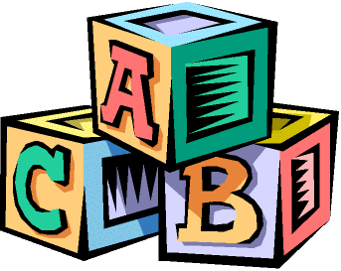 | Investigate and understand vocabulary from across the curriculum.  Understand the features of myths, legends and fables.  Investigate different versions of the same story.  Understand the difference between spoken and written story telling.  Understand the difference between author and narrator.  Examine the treatment of different characters.  Evaluate own work.  Know different forms of poetry.  Recognise how poets create humour in poems.  Become more familiar with significant poets and authors and justify favourite.  Understand the difference between literal and figurative language.  Understand metaphors, idioms and clichés.  Understand that the meaning of words can change over time.  Know types of noun and pronoun.  Know information can be presented in different media e.g. radio, newspaper.  Understand different genres. | Use a neat and joined handwriting style.  Use Linguistic Phonics to develop understanding of sounds and spelling.  Understand basic conventions of Standard English.  Talk about and plan work.  Write own version of myth.  Understand how writing can be adapted for different audiences.  Write poems in particular style.  Create a collection of favourite poems.  Write metaphors.  Use punctuation effectively in writing, including colon and semi-colon | Use questioning for different purposes.  Understand the difference between fact and opinion.  Recognise the value of working with others and helping with their learning.  Articulate a personal response to text.  Read aloud paying attention to audience.  Explain thinking.

 | Number | Measures | Shape & Space | Handling Data
Numeracy  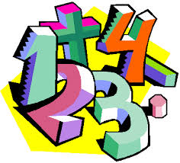 | MENTAL MATHS  Mentally add any two digit numbers.  Mentally find what must be added to any one decimal place number to make the next whole number.  Quick recall of multiplication and division facts.  Mentally find fractions of quantities.  Multiply and divide by 10 and 100.  PLACE VALUE  Count forward and backwards in tenths.  Order numbers up to and beyond 99,999, including numbers with two decimal place.  Know three decimal place numbers.  Find missing numbers in a sequence.  Round numbers to nearest 1000, 100 and 10.  FRACTIONS AND DECIMALS  Know equivalence of fractions, decimals and percentages.  MONEY  Calculate in the context of money.  Discuss and assess value for money when making choices when shopping.  ADDITION AND SUBTRACTION  Complete written addition and subtraction calculations accurately.  Add and subtract fractions with different denominators.  MULTIPLICATION AND DIVISION  Multiply any whole number by 100.  Multiply any two or three digit whole number by a two digit number.  Divide any number by 10.  Solve a range of multiplication and division problems | TIME  Calculate start and finish times and durations.  Use calendars.  Calculate world time differences.  LENGTH  Convert between all metric units of length.  Apply knowledge of metric units to real life contexts.  Investigate how scale is used.  Calculate real life lengths from scale drawings.  WEIGHT  Convert between all metric units of weight.  Apply knowledge of metric units of weight to real life contexts. | Identify 3D shapes from description of properties.  Reflect shapes on horizontal and vertical lines of symmetry.  Visualise 3D shapes which could be formed from given nets.  Understand similarity and congruence.  Calculate the sum of interior angles of 2D shapes.  Understand rotational symmetry. | Interpret pie charts.  Read information from graphs.
Processes
Discuss and respond to open ended questions.
Review and explain own way of working.
Check accuracy of own results and findings.
Explain thinking.
Discuss and share benchmarks for making estimates.

