DROMORE ROAD PRIMARY SCHOOL

GOVERNORS’ REPORT
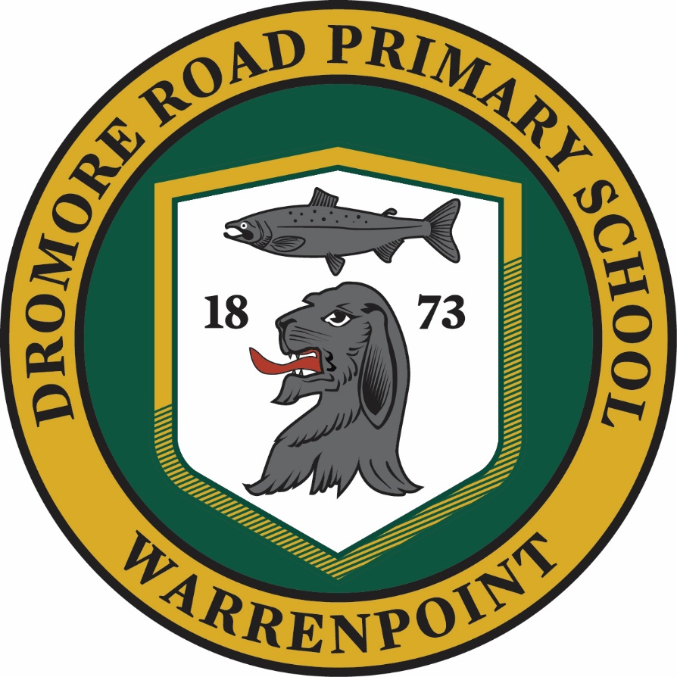
2016/2017
“Together We Can!”
Dear Parent/Guardian,
I am pleased to present to you the Governors’ Annual Report, which is a summary of the activities of Dromore Road Primary School over the last academic year, September 2016 to June 2017. I hope that you find the report both informative and interesting.

For many years, this report was formally presented at the Annual Parents’ Meeting. However, schools questioned the need for this statutory meeting particularly because of the low attendance by parents, and the Government has now recognised this. Accordingly, Article 41 of the Education (NI) Order 2006 repeals the requirement on Boards of Governors in Northern Ireland to hold an Annual Parents’ Meeting. However, in Dromore Road, we have always welcomed parents’ comments and opinions and continue to do so.

As you will discover in this report, Dromore Road Primary School continues to be a busy and thriving school community. The year proved to be a very successful one, during which the standards of teaching and learning and pastoral care were maintained at a high level. The staff, both teaching and nonteaching, continued to work hard to maintain and improve the level of success to which we have all become accustomed. We recognise the commitment and dedication of the teaching and non-teaching staff and would like to thank them for their efforts on our children’s behalf. Thank you also for your ongoing support as we continue to build for the future by working together as staff, parents and pupils.

The Board of Governors also put on record their appreciation of the Parent Teacher Association which does so much to raise the profile of the school in the community, draw parents into the ongoing life of the school and raise money for much needed materials and equipment.

I hope you find this report informative. If you require any further clarification of any aspect of the report please forward your queries in writing to the Principal, Mrs S. Mc Grath.
Yours faithfully,

John Cavan (Chairman)

DROMORE ROAD PRIMARY SCHOOL BOARD OF GOVERNORS
-ooOoo-
Membership 2014 - 2018

CHAIRMAN Mr J H Cavan
SECRETARY Mrs S M McGrath (Principal)

Board Representatives
Mr J H Cavan (Chairman)
Mr R A McCabe

Transferor Representatives
Mrs E Cavan
Mr N McGuffin
Mrs A McCullough
Rev E McKenzie

Parents’ Representatives
Mrs A Berry
Mrs L Smith

Teachers’ Representative
Mrs R McIlroy

The Board of Governors is reconstituted every four years. The present Board of Governors was set up in 2014 and it is anticipated they will serve until 2018.
WHAT ARE THE BOARD OF GOVERNOR’S RESPONSIBILITIES
The Board of Governors of Dromore Road Primary School takes a very keen and dedicated interest in the life and wellbeing of the school, staff and pupils and is ultimately responsible for the overall management of the school. It is required to meet a minimum of three times during the year, but during the 2016 – 2017 school year met 6 times. Some of its duties include:
1) The oversight of the curriculum.
2) The School Policy Statement.
3) Pastoral care including child protection, discipline and attendance
4) The control of the budget.
5) The provision of information to parents.
6) Staff appointments
7) The maintenance of the premises (shared responsibility with the EA).
8) Admissions and enrolments.
9) Fostering links with the local community and pursuing objectives of mutual understanding.
10) Implementing DE and EA circulars.
The Governors are highly supportive of the work of the school and work closely with the Principal and staff to ensure that each child fulfils their potential in all areas of the curriculum.
Dates of Board of Governor’s Meetings 2016 – 2017
12th October 2016
16th November 2016
13th December 2016
28th March 2017
10th May 2017
29th June 2017

Ethos and Aims
Our school motto, ‘Together We Can’ is integral to Dromore Road’s success and in line with ‘Every School a Good School’, we in Dromore Road Primary School aim to provide a warm, welcoming, attractive and stimulating environment which supports pupils’ learning and celebrates their academic and non-academic achievements.
Our teachers are competent and committed to meeting the needs of all pupils. We strive to provide a stimulating and positive environment that is child centred at all times. We aim to treat children as individuals. Everyone is valued and high expectations are held for all. Children are encouraged to believe in their own ability and everyone is encouraged to achieve their highest personal, academic and social goals.

It is our desire to develop an ethos where each member of the school community is sensitive to and caring towards the needs of others. We welcome, celebrate and respect each and every pupil and provide equal opportunities for all. We aim to foster the development of tolerance, responsibility, respect, self-discipline, commitment and sensitivity.

The school seeks, through the Education Reform (NI) Act 1989 to afford every child the opportunity to be educated to his/her full potential aim by providing a broad and balanced curriculum, which develops the skills, concepts and knowledge necessary to prepare our young people for the world in which they live.
We aim to help our pupils:
- To develop as confident, disciplined and enquiring learner, able to make informed choices and decisions.
- To enjoy reading and to develop a confidence with language that enables them to communicate effectively with others.
- To develop the skills and knowledge of mathematics to enable them to cope confidently with everyday situations.
- To develop the ability to handle and communicate information, solve problems, pose questions and be creative through the use of technology.
- To know and understand their world through scientific, historical, geographical and religious inquiry and to come to an understanding of their responsibilities to care for their environment.
- To develop practical, creative, artistic and physical skills.
In achieving these aims, effective leadership is encouraged at all levels throughout the school and the school continually strives to further develop links with home and the wider community.

STAFFING COMPLEMENT 2016 - 2017
TEACHING STAFF
Mrs S McGrath -Principal and P1/2
Mrs L English - P2/P3
Mrs S Newell/Mrs O Graham -P4/5/6
Mrs O Graham/Mrs K Graham - P6/7
Mrs R McIlroy - Learning Support (2 days)
Mrs G McKee - Principal Release (2 days)
Non-Teaching Staff
Mrs M. Vallely – Classroom Assistant P1
Mrs E. Bedzeti - Classroom Assistant P2/ SEN Classroom Assistant/ Lunchtime Supervisory Assistant
Mrs R. Boyd – SEN Classroom Assistant/ Lunchtime Supervisory Assistant
Mrs R. Annett - Classroom Assistant/ Lunchtime Supervisory Assistant
Mrs A. Fraser – SEN Classroom Assistant
Mrs J. Hunter - Lunchtime Supervisory Assistant
Mrs G. McParland – School Secretary
Mrs G. McAnulty – Building Supervisor
Mrs N. Caldwell – Cleaner
The Board of Governors would like to thank all members of staff who contribute so effectively to the smooth running of the school.

BUDGET AND EXPENDITURE REPORT
FINANCIAL YEAR APRIL 2016 – MARCH 2017
With the introduction of Local Management of Schools (LMS) each school receives an annual budget, which is largely based on the number of pupils attending the school. Since April 1992 the LMS budget for Dromore Road Primary School has been fully delegated to the Board of Governors.
Please note that the LMS budget report covers the financial year from April to March as distinct from the academic year from September to June.
- RESOURCES AVAILABLE for 2016/17
£412,996
- EXPENDITURE for 2016/17
£336,667
- 2016 – 17 CUMULATIVE CASH FORWARD
£76,329

DROMORE ROAD PRIMARY SCHOOL FUNDS 2016/17
APRIL 2016- Opening Balance £13975.28
END OF MARCH 2017 Closing Balance £25,492.07*
*This includes PTA funds and Award for All Grant

REVIEW OF THE YEAR
Staffing
During the 2016 – 2017 school year we had no changes to our teaching staff. We had one change in our non-teaching staff and we welcomed Mrs Fraser in a temporary classroom assistant capacity to the staff team. We thank her for her contribution to school life.
Pupil enrolment and Attendance Rate
In September 2016, 15 pupils were admitted to Y1 and this brought our enrolment number to 93 pupils. The annual pupil attendance rate for 2016/17 was 93.1%.
School Leavers
Nine pupils transferred to post primary education at the end of the 2016-2017 school year. 1 to St Mark’s High School; 1 to St Louis Grammar School; 1 to Newbridge and 6 to Newry High School.

2016 - 2017 CALENDAR OF EVENTS
Autumn Term
- INSET Days For Staff
- P6/7 Swimming
- Tag Rugby Demonstration
- Code Club
- Gardening Club
- Hockey
- IFA Football
- Tag Rugby
- Election of ECO council
- Election of School Council
- Newspaper photo of new P1 class
- Library Skills
- School Individual Photos
- P6/7 Slieve Gullion
- P4/7 Titanic, Belfast
- P6/7 Case Programme
- Shared Education
- Flu Vaccination Programme
- PTA Meeting & AGM
- P2/3 Tesco Trip – Farm to Fork
- Harvest Assembly
- Autumn Fayre
- P6/7 Story Telling – Bagenal’s Castle
- Parent Teacher Meetings
- Autumn Kilbroney Park Walk
- NSPCC Assembly & Workshop
- Netball
- Anti-bullying week
- After School Production Class
- Christmas Craft Class
- Anti-bullying training day – Newbridge
- Cancer Focus Workshop
- After school Reading Club
- P7 Taster Day at St Mark’s
- Friendship Four Ice Hockey Belfast
- Waste Bus Workshop
- Mobile Library
- P6/7 First Trust Bank Workshop
- Ceramic Workshop at Seaview Nursery
- Old Mother Hubbard at Warrenpoint Town Hall
- Kilkeel High School Production
- Scholastic Book Fair
- Newry High School Taster Day
- Open Day for New P1 pupils
- Vivo Competition
- Parents’ Assembly
- Mosaic Project
- Flower Arranging Class
- Snow White School Production
- Dress Down Day
Spring Term
- Burns Soccer School Demonstration
- IFA Soccer Assessment P2 & P4
- Piano Caper Lessons
- P6/7 Talk St Mark’s High School
- Galaxy Dancing
- Burns Soccer
- Shared Education
- Credit Union Quiz
- Judo Demonstration
- Safer Internet Day
- Yoga Classes/Kilbroney Integrated
- Waste World
- Football Tournament
- Parent Teacher Meetings
- Homework Club
- P2/3 Library Visit
- P6/7 Craft Club
- P4/6 Library Visit
- Accelerated Reader
- World Book Day
- P6/7 Library Visit
- Dodgeball
- Parent Internet Safety Night
- P4/5 Swimming
- P6/7 Generic PE
- Production at St Mark’s High School
- Girls’ Football at Donard Park
- P6/7 CEOL Project
- P1/2 Assembly
- Knex Challenge
- School Nurse Balance ability
- P1 School Nurse
- Autism Awareness
- Accelerated Reader Parents Evening
- Accelerated Reading
- P2/3 Armagh Planetarium
- Crazy Hat/Hair Dress Down Day

Summer Term
- Shared Education Lessons
- Piano Capers
- School Choir performing at Warrenpoint Church
- Accelerated Reader Club
- Tennis
- P7 Love for Life at Windsor Hill
- Handball
- Hockey
- P6/7 Football Tournament
- Girls Football After School
- P4/5 Swimming
- P3 Relax Kids
- Code Club
- Credit Union Prize Night
- Dance
- RNLI Talk
- P6/7 Newry Council Offices
- Cross Country at Kilbroney Park
- Charity Fun Day & Balloon Race
- P1/2 Nautilus Kilkeel Trip
- P7 St Mark’s HS Induction Day
- Bible Club
- Shared Education – Fairy Glen
- Birds of Prey Demonstration
- P6/7 Bugsy Malone Production at St Dallan’s
- P1/3 Fort Evergreen
- ECO Assessment
- P7 Newbridge Induction Day
- Sports Day at Milltown Playing Fields
- Presentation of Sports Day Medals Assembly
- Opening of new play equipment area
- Induction Afternoon new P1’s
- Marble Jar Winner Treat to Slieve Gullion
- Prize Day and Leaver Assembly
- Presentation of cheque to Shine
- P4/6 Archaeology at Bagenal’s Castle
- P4/7 East Coast Adventure Day
- P7 Mystery Trip
- P7 EWO Transition Talk
- Annual Report Distributed
- Dress Down Day

THE CURRICULUM
The governors are confident that Dromore Road Primary School continues to ensure a safe, secure and stimulating learning environment. Staff expertise and resources are well utilised to assist each child as they strive to reach their maximum potential and the school offers a great variety of learning opportunities suitable to the needs of each pupil. Despite reduced government and EA finance, the staff continued to avail of opportunities for continuing professional development and this has ensured they are kept up to date with the on-going changes and developments within education. During 2016/17 considerable work was carried out in the area of using the Numicon approach in Numeracy and raising standards in reading throughout the school through the use of Accelerated Reader. Aspects of these areas featured in teachers’ professional development through the “Performance Review and Staff Development” (PRSD) scheme. These initiatives were achieved in directed time, after school and on non-contact ‘School Development Days’.
Date of Training | School Development Priorities/ Focus
Baker Days

- 25th August 2016 | Planning
- 26th August 2016 | Role of the Co-ordinator
- 29th August 2016 | Numicon Training
- 30th August 2016 | Assessment – Using data to target underachievers
- 31st August 2016 | Staff Handbook/ review of policies
School Development Days

- 16th September 2016 | Shared Education – Shared Vision
- 26th October 2016 | Accelerated Reader Training
- 4th January 2017 | Literacy/ Numeracy development
- 20th March 2017 | Teaching and Learning Policy
- 24th April 2017 | TESSA Training/ Assessment

Foundation Stage and Key Stage One
Foundation Stage and Key Stage one include pupils from P1 to P4. Pupils are offered a broad and balanced curriculum, with much emphasis on practical experiences. Literacy and numeracy form the main structure of the timetable while other curricular areas are covered through topic work and learning through play.
All pupils in Key Stage one are continually assessed in a range of ways and grouped and taught according to their ability and needs. Statutory assessment is carried out with all P4 pupils.
In addition to classwork, pupils actively participate in special assembly services and end of term productions etc.
Pupils in Foundation Stage and Key Stage one also participated in several class trips throughout the year. All these trips link with their topic work and are listed in the calendar of events.

Key Stage Two
Key Stage two caters for pupils from P5 to P7. Pupils are provided with a broad and balanced curriculum based around the core subjects of literacy and numeracy and extending to all curricular areas. Primary seven pupils also take part in statutory assessment procedures in assessing their skills in Using Maths, Using Communication and Using ICT.
In addition to classwork, Key Stage two pupils participate in morning assembly, special services, Christmas concerts, class trips, swimming lessons, musical tuition and inter-school team matches and a wide variety of after school activities throughout the school year.
In terms of curriculum, considerable work was carried out in the area of Literacy and Numeracy. Our literacy work focus was to raise pupils’ reading attainments. During 2016/17 the school invested in an online programme called Accelerated Reader (AR) for use in Y3-7. Using this programme, pupils are encouraged to read a book and take an online quiz. Immediate feedback is given. Pupils have reacted positively to Accelerated Reader and there is a noticeably greater enthusiasm for reading within the school.

A particularly big thank you to our PTA for helping us to purchase additional reading material for our new central library. This has allowed us to update the range of books we have that are suitable for use in the Accelerated Reader programme.

In numeracy the focus was on encouraging pupils to learn and have quick recall of their number facts and tables and to apply those facts and procedures within a wide range of contexts. Numicon was also purchased as part of Shared Education and was introduced throughout the school.

School Development Plan
In line with their statutory requirements the Board of Governors produced a new Development Plan for Dromore Road Primary School in the Autumn term of 2015, to run until 2018. The plan is amended during the three years to take account of the changing needs of the school. Questionnaires were available for all parents to record their opinions and ways in which they felt the school could be improved. The school has set targets to effect school improvement in line with the DENI initiative.

Policies
The staff, in consultation with pupils, parents and governors, have produced a wide range of pastoral care and curriculum policies that are suited to the needs of current legislation, good practice and the NI curriculum. Last year the Pupil Attendance Policy, Safeguarding and Child Protection Policy, Cold Weather Policy, Critical Incident Policy, Anti-bullying, First Aid Policy, Intimate Care Policy, Reasonable Fore and Safe Handling, Positive Behaviour Policy, Relationship and Sexuality Policy, Admission Policy and Absconding Policy were all reviewed and amended were necessary. Stakeholders have been consulted on these. All other policies may be obtained from the school.

ASSESSMENT OUTCOMES OF PUPILS DURING SCHOOL YEAR 2016/17
One of the most significant aspects of the Education Reform Order has been the introduction of statutory assessment for all children in primary schools at the end of Key Stage 1 (P4) and the end of Key Stage 2 (P7). In June 2017 all P4 and P7 pupils in Dromore Road Primary School, were given a ‘level’ in Using Communication, Using Mathematics and ICT. Unfortunately, due to an on-going dispute over Assessment in Primary Schools, Teacher Unions have recommended that schools do not report levels to the Department of Education and as over 75% of schools did not submit key stage levels in 2016/17 it makes any comparison of data difficult and unreliable. In Dromore Road, pupils’ individual levels were reported to parents with their June school reports. The overall school results for Dromore Road were as follows:

KEY STAGE 1
[COMMUNCIATION]
Number of Children attaining | Outcomes - %
Level 2 and above | 70%
Level 3 | 30%

[USING MATHEMATICS]
Number of Children attaining | Outcomes - %
Level 2 and above | 90%
Level 3 | 40%

KEY STAGE 2
[COMMUNCIATION]
Number of Children attaining | Outcomes - %
Level 4 and above | 88.9%
Level 5 | 11.1%

[USING MATHEMATICS]
Number of Children attaining | Outcomes - %
Level 4 and above | 77.7%
Level 5 | 33.3%

Special Needs
It is an aim of Dromore Road Primary School to ensure that every child, regardless of ability, has access to a broad and balanced curriculum - this, of course, includes children with special educational needs.
In order to make appropriate provision for these children Dromore Road School will follow the stages laid down in the Code of Practice as outlined in the Education (Northern Ireland) Order 1996, together with statutes laid down in the Special Educational Needs and Disability Order (2005).
Special Educational Needs Co-ordinator (SENCO), class teachers and special needs support teachers and classroom assistants work closely together to ensure early identification of special needs, targeted programmes of work and deployment of external agencies if appropriate.
School Liaison
Links between the school and parents and the school and the community continue to be fostered and encouraged in various ways.
All new P1 pupils together with their parents visited the school prior to admission, in order to meet their teacher and view the classroom. Information regarding the school’s policies, practices and procedures was also shared with new parents in the form of an information booklet.
The school website was maintained and developed to help keep parents up to date with happenings in school. Letters were sent out by the Principal and teachers. In addition a range of parents’ meetings were held during the year to provide detailed information on specific topics, for example, e-safety and Accelerated Reader.
Formal parent/teacher interviews were held in October with a second interview offered in February. A written school report was issued in June.
Liaison continued between Dromore Road and the various post-primary schools in the district. Pupils attended Open Days at the various post-primary schools and representatives from St Mark’s High School, Kilkeel High School, St Louis Grammar School and Newry High School visited or communicated with the school to liaise about transferring P7s. In addition, links continued with post primary schools and further education colleges when students from these establishments spent time on work experience in Dromore Road.
Local ministers continued to participate in school assemblies and provided denominational RE for relevant pupils. This added significantly to the spiritual dimension of the school.
The school is extremely fortunate to continue to have such a hard-working and dedicated Parent Teacher Association who continue to work together to raise funds for our school through a variety of fundraising events including the Autumn Fayre, Christmas Hamper and Balloon Race.

Extra-Curricular Activities

Dromore Road Primary School has a well-deserved reputation for extensive extracurricular provision. The teachers run clubs throughout the year and these are normally full to capacity. During the 2016/17 year, we continued to develop our after school provision for pupils in P4-7. Pupils had the opportunity to avail of a range of activities such as Code Club, Gardening Club, Hockey, Tag Rugby, Netball, Christmas Craft, Drama, Dance, Soccer, Accelerated Reader Club, Dodgeball, Craft Club, Homework Club, Tennis, Girls Football and Handball. Thank you also to both Mr Smith and Ms Woods for volunteering their time in helping out with our after-school provision.

Extended Schools
Dromore Road is very fortunate to be able to offer a number of activities through ‘The Extended Schools' programme. All the programmes funded through this programme aim to promote:
- Being Healthy
- Enjoying Learning and Achieving
- Living in Safety and with Stability
- Enjoying Economic and Environmental Well-Being
- Contributing Positively to Community and Society
The school was able to offer a daily 321 Club to facilitate younger pupils in P1-3 to be engaged in a range of exciting activities between 1:30-2:50pm. We also used extended school funding to provide additional after school activities by outside agencies such as Galaxy Coaching.
As part of our involvement in the Extended Schools cluster, with the other schools in the area, a group of P6/7 contributed work to a joint mosaic project. Over a number of weeks, the pupils worked with St. Mark’s staff to create a mural of all the Extended Schools’ crests. This is now proudly hanging in the schools’ entrance hall.
Parent classes were also offered to promote health and well-being and both the Christmas Craft and Yoga classes were well attended.

Shared Education
Our school reflects the mix of denominations in society and we try to forward this policy at any opportunity. The School proactively develops links with other schools in the area to take part in projects and activities and Dromore Road has a long history of working alongside St Bronagh’s Primary School in Rostrevor. We value the relationship between the two schools and pupils regularly have shared lessons together. During 2016/17 our shared lessons with St Bronagh’s focused on Number and the use of Numicon to encourage active engagement from the learner to think mathematically, choosing what to do and how to do it.
Staff from both schools also worked together during a School Development Day in September 2016 to create a shared vision, "MOVING FORWARD TOGETHER WITH TOLERANCE AND RESPECT".

Pupil Council
Pupil Council members for 2016– 2017 school year were: Josh Cowan, Kirsty Knox, Sofie Keenan, Karim Zerai, Matthew Smith and Ashley Bedzeti.
Regular meetings were held with Mrs K Graham to discuss school matters which the children in school have put forward. The pupils also reported to the Board of Governors in June 2016.

Eco Council
The Eco Council is made up of interested pupils from throughout the whole school and last year 15 pupils acted as Eco Warriors. The children in our Eco Council have made many positive changes to our school environment and have continued to focus this year on Energy, Biodiversity and Recycling. During 2016/17 they have been particularly proactive in improving the effectiveness of recycling within the school and have done so by introducing a new bin system to each classroom. A new wormery was also purchased for our newly created play area to encourage the school community to explore biodiversity. Our Eco representatives have also continued to look after the school garden and each class were allocated an area to plant flowers, fruits and vegetables. The whole school community also worked together to maintain the garden by weeding and watering plants. All our hard work has paid off and we were delighted that our Eco flag was renewed in June 2017!

SCHOOL SPORT
1996 regulations require formal information to be presented regarding school sport. The aims for school sport as outlined in the school prospectus are fulfilled through physical education curriculum time, together with an extensive range of extra-curricular sport.
Children are timetabled for PE below and activities include athletics, dance, gymnastics and games:-
- P1/3 –2 x 30-40min sessions per week
- P4/7 – 2 x 40-50 min sessions per week

Children from P4 to P7 participated in an annual 10 week swimming programme at Kilkeel Leisure Centre.
The school offers sporting as part of the PE curriculum and after school activities. Sports available at Dromore Road Primary School are athletics, gymnastics, hip-hop dancing, cycling proficiency, dodgeball, football, hockey, netball, tennis and other games.
Throughout the year, we also implemented the "daily mile" scheme to improve the health and concentration of pupils. The extra 15 minutes of exercise a day is in addition to PE classes and is not timetabled; teachers take their classes out at a time of their choosing.
School Security
1998 regulations require formal information to be presented regarding school security. Please note the following:
1) Visitor access control - during school hours all visitors to school must enter by the front door and report to reception. The front door is protected by an electronic access control. A closed circuit television system operates on school premises.
2) Secure doors and windows - external doors are secured from the inside when pupils are in class and locked when school is not in use. Double glazed windows are fitted with safety / security handles.
3) Out of hour’s access - there are three keyholders – Building Supervisor, Secretary and Principal.
4) Fire Detection Systems - the school is fitted with a fully functional fire alarm.
5) Cash handling - a safe is installed in school for this purpose.
6) Computer security - information held on computer can only be accessed by using confidential passwords. A “Safe Use of the Internet” policy operates in school.
7) Intruder Alarm - the school is protected by an intruder alarm.
An assessment is carried out annually by the Board of Governors and forwarded to the EA.
School Safeguarding
The school safeguarding team are:
Mrs Sharon McGrath – Principal
Mrs Louise English – Designated Teacher for Child Protection
Mrs Karen Graham – Deputy Designated Teacher
Regular updates are given to the BoG at every meeting and all staff received training in November 2016. The BoG endorse that Dromore Road Primary reflects the safeguarding guidance set out by the Department of Education and impacts positively on learning, teaching and outcomes.

School Premises
The Governors, with the assistance of the EA Architects and Maintenance Departments continued to maintain the school building and grounds. This year, building work took place to adapt the disabled toilets to facilitate the use of a changing bench. The school also secured an ‘Award for All’ grant of £9990 which the school has used to install a fantastic outdoor play area which is utilised by the Foundation Stage classes and KS1 during structured play.

THANK-YOU
The Governors wish to record a very special thank you to the Principal and staff (teaching and non-teaching) here in Dromore Road PS. We are blessed with a committed, hard-working and dedicated team. In everything they do, the children are considered first and we thank each and every one of them for their commitment to this school and for the support they continue to give to the Principal.

Thanks also to our team of lunchtime supervisors for their care and supervision during that busy part of the day and the way in which they have embraced our new playground games arrangements.

Our school premises continue to be very well maintained. The Board of Governors would like to thank Mrs Mc Anulty and Mrs Cardwell who have ensured a high standard of maintenance of the school and its grounds.

Finally, we’d like to say a special thank you to all parents. You continue to support our efforts so enthusiastically and you have continued to listen and trust us with your children’s education. Our pupils, parents, teachers and governors continue to work as a team and this partnership will continue to develop as we aim to provide every child with a safe, happy and stimulating learning environment, where every child is working to their full potential.

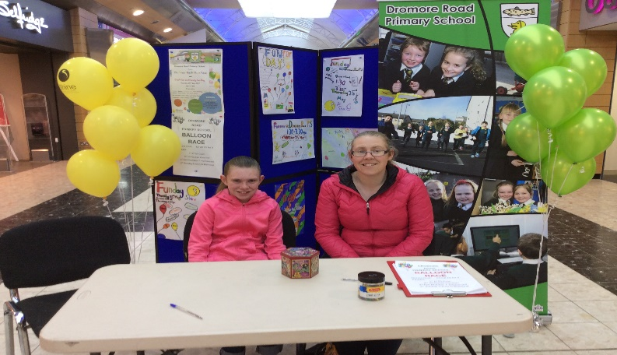
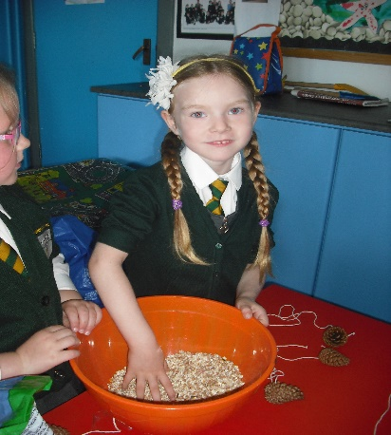
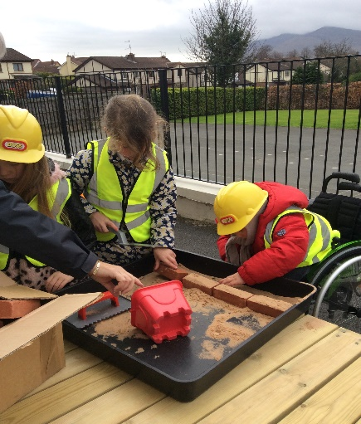
‘Together we can.’

