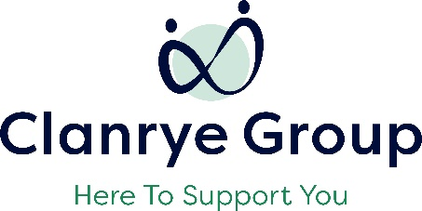

Parents Plus Special Needs Programme
Enrolment Form (Parents/Carers in attendance)
Priority for this programme will be given to families known to the Southern Trust Autism and Disability Services. However referrals will be considered from all families living in the Southern Trust with a young person 11-18 years, with a confirmed Autism diagnosis. Applicants will be notified within a week of the closing date. A list may be created for future programmes.
Participant Details (Parent/Carer)
Name
Address

Contact Number/Email
Relationship to young person
Young Persons Details
Name
DOB/Age
Does your young person have a confirmed diagnosis of Autism? | Y/N
Please provide brief information including any additional needs that need to be given consideration to
Is the young person currently known to the Southern Trust Autism Services or Social Work Disability Services? | Y/N
Additional Detail-Parent/Carer
Are you in a position to attend this 7 week programme | Y/N
This programme will be delivered online, do you have access to the internet? | Y/N
Do you require any reasonable adjustments in relation to your application, eg access arrangements, interpreting service? | Y/N
Would you like to have a call back from one of the programme facilitators before committing to the programme? | Y/N
Consent
Form completed by
Date
If not completed by Parent/Carer) please confirm that consent has been given to submit this application?

Thank you for taking the time to complete the form.

Please return to claire.convery@clanryegroup.com
by Tuesday 29th August 2023

