Term:- 1B Date: November/December 2017
TOPIC - Ourselves
 | Reading | Writing | Talking & Listening
Literacy  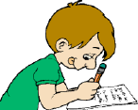 | - Explore narrative order, e.g. identify and map out the main stages of the story:- introduction , -build up, -climax and resolution.  - Understand the concept of chronology in narrative, noticing how time has passed.  - Study a range of poems on similar themes.  - Know and understand the terms which describe different kinds of poems, e.g. ballad, sonnet, rap, elegy, narrative poem and to identify typical features.  - Identify how texts read are organised into paragraphs.  - Identify verbs, nouns and speech marks when reading.  - Read with increased fluency and expression.  - Find synonyms for adjectives identified in their reading. | - Investigate different ways of planning stories e.g mind maps, story ladders, thought shower etc...  - Begin to organise writing into paragraphs.  - Write a simple non-chronological report linked to topic of ‘Ourselves’. Include diagrams, labels etc..  - Write own poems based on personal or imagined experience, linked to  poems read.  - Make improvements to their work – independently and when prompted.  - Use speech bubbles as a way of presenting speech.  - Compile a class anthology of favourite poems justifying preference. | - Speak clearly to a range of audiences.  - Talk about what they are learning and how it might be improved.  - Understand and learn to respond to feedback.  - Understand and use the rules needed to participate in group discussion.  - Choose and prepare poems and songs for performance. Recite/perform with suitable expression/speed/volume.  - Take on the role of someone else e.g. a character from a book/story  - Respond in role during hot seating or conscience alley activities.

 | Number | Measures | Shape & Space | Handling Data
Numeracy  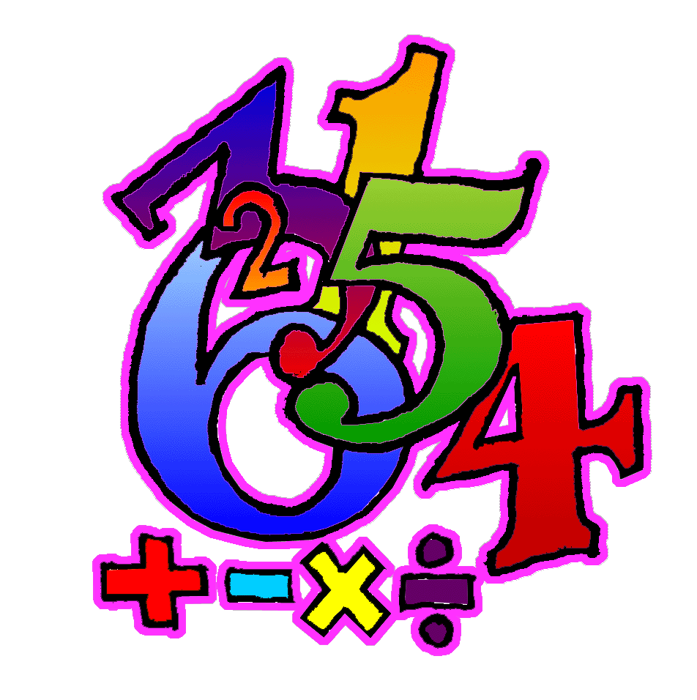 | - Count, recognise, read, write, order and work with numbers within 99999.  - Know whole number before/after/ between 1 decimal place numbers.  - Find missing numbers in a sequence of 1 decimal place numbers (increasing and decreasing)  - Understand mixed numbers as whole numbers plus a fraction.  - Add/subtract fractions with the same denominator.  - Use written multiplication methods to multiply any whole number by any single digit number, answers within 99 999, estimating the answer before calculating.  - Develop a written method for division calculation within 99 999, estimating the answer before calculating.  - Solve a range of multiplication and division problems, using both written and mental methods, selecting the operation required.  - Understand and use the concept of factors.  - Calculate change required when buying items, paying with amounts up beyond £100. | - Understand the concept of volume as a measure of how much space an object takes up.  - Understand conservation of volume.  - Understand that a square metre is a square where each side is 1 m in length, and that it has an area of 1 m² .  - Estimate and measure larger areas using m² .  - Convert between 12 and 24 hour time system. | - Understand and use terms horizontal, vertical, perpendicular, parallel.  - Understand that a whole turn is divided into 360⁰ and use to calculate degree equivalents of one, two, three right angles; quarter, half, ¾ , and full turns. | - Interpret pie charts using fractions up to 10ths to work out proportions and quantities of a total.  - Extend range of vocabulary when describing likelihood of events.
Processes: (Ongoing throughout the year, but all processes activities this term will be linked to areas covered above as well as revising previous concepts).
- Select and use materials and equipment required for their work.
- Identify and collect information required for a task, initially with teacher support.
- Suggest ways a task might be approached.
- Plan own work and work systematically.
- Suggest how to present findings.
- Begin to choose a format to record work and give reasons for the choice.
- Begin to present findings using prose, numbers and symbols, to show how the problem was solved/investigation was carried out.
- Begin to use appropriate language to describe orally their work.
- Explore and use a range of problem solving strategies, persevering when difficulties are encountered.
- Review and explain own way of working.
- Check accuracy of own results and findings.
- Explain their thinking.
- Compare methods of presentation and discuss which shows the results most clearly.
- Discuss a general statement with teacher/peers and check whether particular cases match it.
15. Discuss and share benchmarks for making estimates.

