Term:- 1B Date: November/December 2017
TOPIC - Ourselves
 | Reading | Writing | Talking & Listening
Literacy | - Explore narrative order, e.g. identify and map out the main stages of the story:- introduction , -build up, -climax and resolution.  - Understand the concept of chronology in narrative, noticing how time has passed.  - Study a range of poems on similar themes.  - Know and understand the terms which describe different kinds of poems, e.g. ballad, sonnet, rap, elegy, narrative poem and to identify typical features.  - Identify how texts read are organised into paragraphs.  - Identify verbs, nouns and speech marks when reading.  - Read with increased fluency and expression. | - Investigate different ways of planning stories e.g mind maps, story ladders, thought shower etc...  - Begin to organise writing into paragraphs.  - Write a simple non-chronological report linked to topic of ‘Ourselves’. Include diagrams, labels etc..  - Write own poems in the style of one of those studied.  - Use speech bubbles as a way of presenting speech. | - Speak clearly to a range of audiences.  - Talk about what they are learning and how it might be improved.  - Understand and learn to respond to feedback.  - Understand and use the rules needed to participate in group discussion.  - Choose and prepare poems and songs for performance. Recite/perform with suitable expression/speed/volume.  - Take on the role of someone else e.g. a character from a book/story

 | Number | Measures | Shape & Space | Handling Data
Numeracy  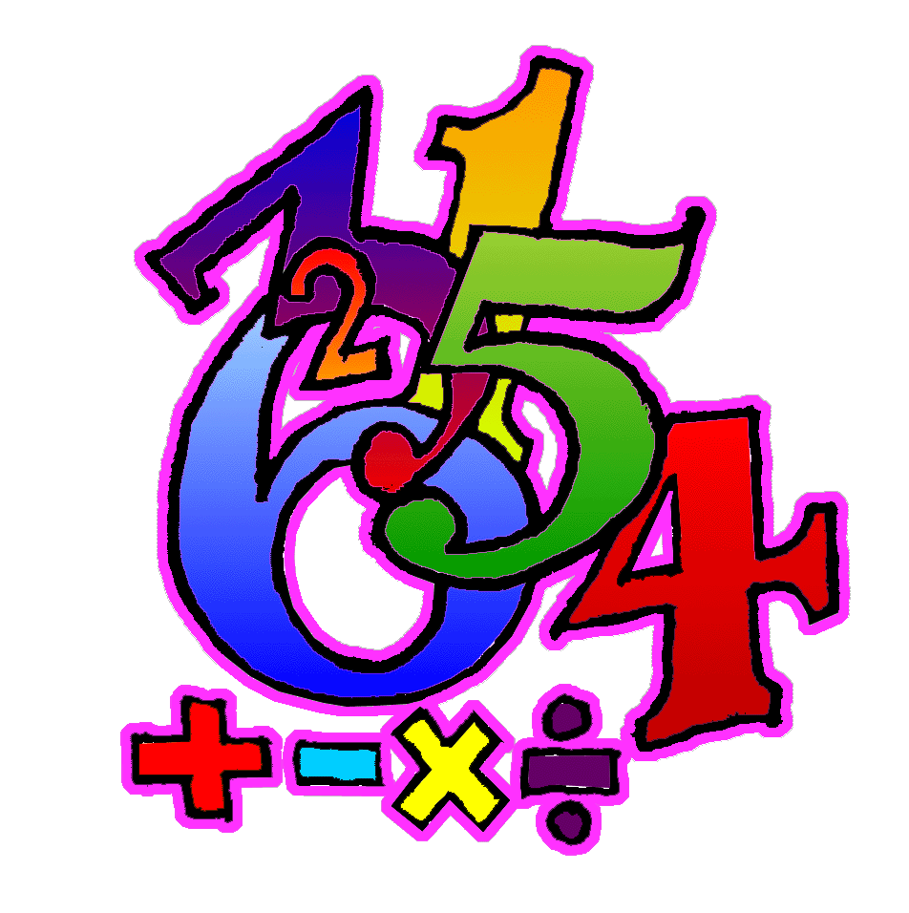 | - Count, recognise, read, write, order and work with numbers within 9999.  - Recognise, read and writefractions, identifying numerator and denominator.  - Solve a range of addition and subtraction problems, using both written and mental calculations.  - Use knowledge of 3,4,5 and 10 times multiplication facts to derive corresponding division facts and use to solve a range of multiplication and division problems.  - From 3 given numbers, derive 2 multiplication and 2 division facts.  - Use function machines to reinforce quick recall of addition, subtraction, multiplication and division facts.  - Add, subtract and multiply amounts of money up to£100 and calculate change required when buying items within this bracket. | - Estimate, measure and record weights using litres and millilitres.  - Understand that a square cm is a square where each side is 1cm in length, and that it has an area of 1square cm.  - Estimate and measure areas using the square cm as a standard unit, by counting the squares, where the area:  - Is an exact number of complete cm squares.  - Is made up of whole and half cm squares.  - Using analogue and digital clock times to 5 minutes, calculate what time it will be, or was. E.g. The clock says 9:25. What time was it 20 minutes ago? What time will it be in 15 minutes. | - Identify 3D shapes from 2D drawings.  - Use co-ordinates to identify a point.  - Sort, name, recognise and describe 2D shapes, using number and length of sides, number of corners, number of right angles, number of lines of symmetry, stating whether they are regular or irregular. | - Interpret pie charts using halves, quarters, thirds, fifths to work out what proportion of the total chart it represents.  - Continue to use ICT programmes to represent data in a variety of ways.
Processes: (Ongoing throughout the year, but all processes activities this term will be linked to areas covered above as well as revising previous concepts).
- Begin to organise own work and to work systematically.
- Solve simple two-stage problems set in real life contexts.
- Begin to suggest how to present findings.
- Use a writing frame to plan what is needed to start solving a problem.
- Talk about how they carried out a task.
- Discuss and respond to open ended questions.
- Discuss and compare ideas and methods with others.
- Where appropriate, select or design a writing frame to plan work.
- Explain their thinking.
- Compare own methods/findings/presentation with that of others.
- Begin to explore and use a range of problem solving strategies, persevering when difficulties are encountered.
12. Check accuracy of own work and findings

