Dromore Road Primary School
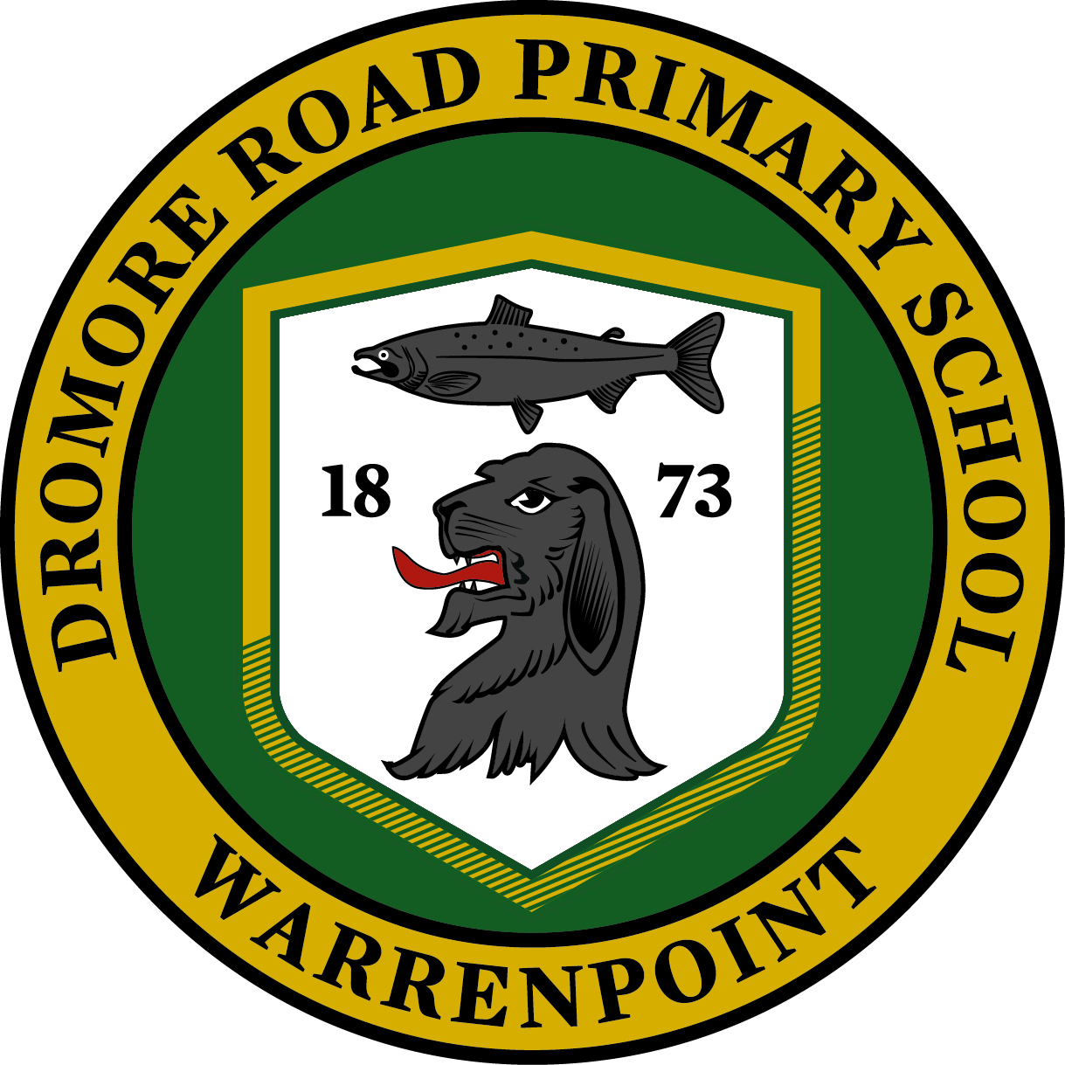

Curriculum
Policy
In Dromore Road, we follow the requirements of the Northern Ireland Curriculum providing for a broad and balanced curriculum for all children, giving them the opportunity to experience success in learning and to achieve as high a standard as possible.

The primary school curriculum is organised around three key stages:
- The Foundation Stage Years 1 and 2 (P1 and P2)
- Key Stage 1 Years 3 and 4 (P3 and P4)
- Key Stage 2 Years 5, 6 and 7 (P5 – P7)

An emphasis is p l a c e d on the progressive development of pupils’ skills and capabilities through opportunities to engage in active learning across the following six Areas of Learning:

- Language and Literacy (including Talking and Listening, Reading and Writing; schools are also encouraged to teach additional languages);
- Mathematics and Numeracy (focusing on the development of mathematical concepts and numeracy across the curriculum);
- The Arts (Art and Design, Drama and Music)
- The World Around Us (focusing on the development of knowledge, skills and understanding in Geography, History, Science/Technology)
- Personal Development and Mutual Understanding (focusing on emotional development, social skills, learning to learn, health, relationships and mutual understanding in the local and global community);
- Physical Education (focusing on the development of knowledge, skills and understanding through play and range of physical activities).

AIMS AND OBJECTIVES
In Dromore Road Primary School we endeavour to successfully implement the overall aim of the Northern Ireland Curriculum which is to “empower young people to develop their potential and to make informed and responsible choices and decisions throughout their lives”. By so doing, our objectives are to provide learning opportunities which will help them to develop as individuals, contributors to society, and to the economy and environment.
Objectives
The learning opportunities provided through the Northern Ireland Curriculum should help young people to develop as:

Individuals | Contributors to Society | Contributors to the Economy and Environment
Throughout the primary stages teachers help children to:  - Develop self-confidence, self -esteem and self-discipline  • Understand their own and others’ feelings and emotions. • Develop the ability to talk about how they feel.  • Develop their motivation to learn and their individual creative potential.  • Listen to and interact positively with others  • Explore and understand how others live.  (Personal/Mutual Understanding) | Throughout the primary stages teachers help children to:  • Become aware of some of their rights and responsibilities.  • Become aware of some of the issues and problems in society.  • Contribute to creating a better world for those around them.  (Citizenship) | Throughout the primary stages  teachers help children to:  - Develop literacy, numeracy and ICT skills  - Develop their aptitudes, abilities and creatively.  - Be willing to expand their  learning and performance  throughout their lives.  - Work independently and as a  member of a team.  - Develop perseverance, initiative and flexibility.  - Be willing to take calculated risks when appropriate.  - Use critical and creative thinking to solve problems and make decisions.  - Identify the main reasons why people set up their own business.  (Employability)
• Have an understanding of healthy eating and the importance of exercise.  • Develop positive attitudes towards an active and healthy lifestyle, relationships, personal growth and change.  • Become aware of key issues which affect their physical, social and mental well-being and that of others.  • Develop an awareness of their own personal safety.  (Personal Health) | • Develop an awareness and respect for: - the different lifestyles of others - similarities and differences in families and people in the wider community.  • Understand some of their own and others’ cultural traditions.  • Be aware of how we rely on each other.  (Cultural Understanding) | - Learn to manage their money and build up savings.  - Interpret information in order to make informed choices as consumers.  - Develop an understanding of the importance of using resources carefully in the classroom.  (Economy)
• Develop an awareness of right and wrong.  • Develop an awareness of how their actions can affect others.  • Understand that values, choices and decisions should be informed by a sense of fairness.  • Take responsibility for their actions.  • Develop tolerance and mutual respect for others: (Moral Character) | • Be aware of and use information available to us through all sorts of media.  • Become aware of the potential impact of media in influencing our personal views, choices and decisions.  (Media Awareness) | - Develop an awareness of some environmental issues.  - Appreciate the environment and their role in maintaining and improving it.  - Understand how actions can affect the environment. (Education for Sustainable Development)
• Develop a sense of awe and wonder about the world around them.  (Spiritual Understanding) | • Become aware of the imbalances in the world around us, at both a local and global level.  • Become aware of the potential impact of developments upon the lives of others.  (Ethical Awareness)

WHOLE SCHOOL SKILLS AND PERSONAL CAPABILITIES
In Dromore Road Primary School we place an emphasis on the development of skills and capabilities for lifelong learning and for operating in society. We provide opportunities for children to engage in active learning contexts across all areas of the curriculum and progressively develop:-
Cross – Curricular Skills:-
1) Communication
In Dromore Road, children develop communication skills which will enable them to express themselves socially, emotionally and physically, to develop as individuals, engage with others and contribute as members of society. We teach Communication through a variety of modes which include, talking and listening, reading and writing, non-verbal modes, wider literacy and the use of multimedia and ICT.

Talking and Listening
In Dromore Road pupils will be enabled to:
- listen to and take part in discussions, explanations, role plays and presentations;
- contribute comments, ask questions and respond to others' points of view;
- communicate information, ideas, opinions, feelings and imaginings, using an expanding vocabulary;
- structure talk so that ideas can be understood by others;
- speak clearly and adapt ways of speaking to audience and situation;
- use non-verbal methods to express ideas and engage with the listener.

Reading
In Dromore Road pupils will be enabled to:
- read a range of texts* for information, ideas and enjoyment;
- use a range of strategies to read with increasing independence;
- find, select and use information from a range of sources;
- understand and explore ideas, events and features in texts*;
- use evidence from texts* to explain opinions.
* Texts refer to ideas that are organised to communicate and present a message in written, spoken, visual and symbolic forms.

Writing
In Dromore Road, pupils will be enabled to:
- talk about, plan and edit work;
- communicate information, meaning, feelings, imaginings and ideas in a clear and organised way;
- develop, express and present ideas in a variety of forms and formats, using traditional and digital resources, for different audiences and purposes;
- write with increasing accuracy and proficiency.

2) Using Mathematics
Using Mathematics is the skill of applying mathematical concepts, processes and understanding appropriately in a variety of contexts and in real life situations. In Dromore Road, children will be given opportunities to transfer their understanding of mathematical knowledge to other contexts of the curriculum.

Across the curriculum, at a level appropriate to their ability, pupils will be enabled to:
- choose the appropriate materials, equipment and mathematics to use in a particular situation;
- use mathematical knowledge and concepts accurately;
- work systematically and check their work;
- use mathematics to solve problems and make decisions;
- develop methods and strategies, including mental mathematics;
- explore ideas, make and test predictions and think creatively;
- identify and collect information;
- read, interpret, organise and present information in mathematical formats;
- use mathematical understanding and language to ask and answer questions, talk about and discuss ideas and explain ways of working;
- develop financial capability;
- use ICT to solve problems and/or present their work.

- Using Information and Communication Technology
Information and Communication Technology (ICT) is used within Dromore Road to enable children to handle and communicate information, solve problems, pose questions and take risks showing an awareness of audience and purpose. Opportunities will be provided for children to use ICT to collaborate within and beyond the classroom, to share and exchange their work and to exhibit and showcase their learning.

Dromore Road will develop children’s ICT skills according to ‘The Curriculum Requirements for Using ICT’ as set out under headings often described as the 5 'E's. These are -

Explore - (access/manage data, research/select/process and interpret information, investigate/predict and solve problems and how to keep safe and display acceptable online behaviour)
Express - (create/develop/present and publish ideas and create information and multimedia products)
Exchange - (communicate using contemporary methods and tools, share, collaborate, exchange and develop ideas digitally)
Evaluate - (talk about, review and make improvements to work, reflecting on the process and outcome)
Exhibit - (manage and present their work, showcase their learning across the curriculum)
Explore and Express form the core of most activities that our pupils will be involved in. However, in our planning we will build in Evaluate (for pupils to consider what they have done) and also provide opportunities for them to Exchange (work collaboratively online) and to Exhibit (showcase their work digitally).

- Thinking Skills and Personal Capabilities
Personal Skills and Capabilities underpin success in all aspects of life and the Northern Ireland
Curriculum and within Dromore Road Primary School children develop thinking skills and personal
capabilities by application of the following Statutory Requirements:

- Thinking, problem-solving and decision making (sequencing, ordering, making predictions, justifying methods, justifying methods, evaluating outcomes)

- Self Management (setting targets, organizing and planning, sustaining attention, reviewing learning, managing their time, seeking advice)

- Working with others (listening actively, respecting views and opinions of others, using negotiation and compromise, suggesting ways to improve)

- Managing Information (selecting, classifying comparing and evaluating, collating, recording and representing information, awareness of audience)

- Being Creative (experimenting with ideas, taking risks in learning, learning from and valuing other people’s ideas)

AREAS OF LEARNING
LANGUAGE AND LITERACY
Our Literacy programme is aimed at developing a child’s ability to understand and use language. It focuses on the skills necessary for children to interact effectively with the world around them, to express themselves creatively and to communicate confidently both orally and in writing. Pupils will be given opportunities to:
• develop their talking and listening skills;
• participate in a modelled, shared, paired and guided reading activities, read a wide range of texts for enjoyment and learning; use a range of comprehension skills;
• write independently for a range of audiences and purposes, engaging in planning, using legible handwriting, using a variety of skills to spell correctly.
Dromore Road’s Literacy Coordinator is Mrs O Graham. The Coordinator is responsible for formulating a Literacy Policy, writing Literacy Action Plans, ensuring Literacy is within the School Development Plan, analysing data (NRIT/PTE etc), reviewing and monitoring literacy teaching and learning, planning in-service training and maintaining resources etc.

NUMERACY
Our Numeracy programme is aimed at developing Maths as a life skill across the curriculum. It focuses on developing the children’s knowledge, skills and understanding as well as their ability to apply mathematical learning and solve problems. Pupils will have the opportunity to learn through discussion, practical activities and written tasks and be engaged in:
• exploring and investigating;
• doing and observing;
• talking and listening;
• asking questions;
• reading and recording.
Mrs Newell is the Numeracy Co-ordinator. She is responsible for formulating a Numeracy Policy, writing Numeracy Action Plans, ensuring Numeracy is within the School Development Plan, analysing data (NRIT/PTM etc), reviewing and monitoring Numeracy teaching and learning, planning in-service training and maintaining resources etc.

INFORMATION & COMMUNICATION TECHNOLOGY (I.C.T.)
Our I.C.T. programme is aimed at encouraging pupils to develop I.C.T. skills across the curriculum which will enable them to:
- access and manage data;
- research, select, process and interpret information;
- create, develop, present and publish ideas and information using a range of digital media;
- create a range of multimedia products;
- communicate using a range of contemporary methods;
- understand how to keep safe when working online.
The ICT Co-ordinator is Mrs. English. She is responsible for formulating an ICT Policy, writing ICT Action Plans, reviewing and monitoring ICT teaching and learning, planning in-service training and maintaining resources etc. She is also responsible for e-safety within the school.

THE WORLD AROUND US
‘The World Around Us’ provides our pupils with exciting and relevant contexts for learning.
It combines aspects of Geography, History and Science and Technology and ensures that the children have opportunities to explore, investigate and think about their world – past, present and future.

Learning about ‘The World Around Us’ provides opportunities for our pupils to develop:
- self-confidence and self-esteem in expressing and sharing their thoughts and ideas;
- an appreciation of the beauty and wonder of the world;
- an awareness of themselves and their place in the world;
- an awareness of other places and cultures;
- an awareness of the environment;
- an awareness of ICT and its impact on society and the world around them.

Where possible, ‘The World Around Us’ (WAU) will be taught through cross-curricular topics and linked to the other areas of the curriculum. It will also enhance and promote learning within Literacy and Numeracy.

Mrs Newell is the Coordinator and is responsible for formulating a WAU Policy, reviewing and monitoring teaching and learning within WAU, identifying priorities, planning in-service training and maintaining resources etc

PERSONAL DEVELOPMENT & MUTUAL UNDERSTANDING
Our P.D.M.U programme is aimed at encouraging each child to:
• develop personally, emotionally, socially and physically;
• lead healthy, safe and fulfilled lives;
• become confident, independent and responsible citizens, making informed decisions and responsible choices throughout their lives.
It provides the opportunity to focus on emotional development, health and safety, physical activity & exercise, relationships with others and the development of moral thinking, values and action. Where possible, ‘Personal Development & Mutual Understanding’ will be linked to learning in the other areas of the curriculum and to our Shared Education Programme. Mrs English is the PDMU Coordinator and also has responsibility for co-ordinating our Shared Education Programme with St Bronagh’s Primary School, Rostrevor.

THE ARTS
‘The Arts’ provide opportunities for developing pupils’ creativity, enabling them to express their ideas, feelings and interpretations of the world through pictures, sound, drama & dance. There are three aspects to ‘The Arts’:
- Art and Design
- Music
- Drama

ART & DESIGN
Pupils will be given opportunities to:
• respond to their personal experience, memory and imagination;
• examine the work of artists and designers from their own and other cultures;
• develop their understanding and use of visual elements to communicate their ideas;
• use a range of materials, tools and processes, including drawing, painting, print-making, malleable materials, textiles and 3-D construction;
• evaluate their own work and that of others.
Mrs McIlroy is the Art and Design Coordinator.

MUSIC
Pupils will be given opportunities to:
• work creatively with sound & imaginative play;
• sing and perform with simple instruments;
• listen and respond to their own music and that of others;
• express their thoughts, ideas and feelings;
P4 – P7 receive the opportunity for instrumental tuition for strings through the E.A’s Music Service and all pupils in P3-7 have the opportunity to learn to play the recorder. Our choir performs at our Carol Service, Concerts and other local community events. Our Music Coordinator is Mrs Mc Grath.

Drama
Pupils will be enabled to:

- express thoughts ideas and feelings;
- develop their creativity;
- take part in a range of drama games and strategies.
- develop their understanding of the world by engaging in a range of creative and imaginative role play situations;
- develop dramatic skills appropriate to audience, context, purpose and task by exploring voice, movement, gesture and facial expression through basic exploration of a specific role, and by structuring dramatic activity to make meaning clear for a chosen audience.

PHYSICAL EDUCATION
In Dromore Road our PE programme is aimed at developing pupils’:
• knowledge, skills and understanding in a range of physical activities;
• self-confidence and self-esteem as individuals and members of a team;
• personal qualities such as taking responsibility, fairness and working with others;
• an understanding of the relationship between physical activity and good health.
Each class has regular PE lessons each week for which they must change into suitable clothes - T-shirt, shorts and PE shoes. A note must be brought if a child is unable to participate in a PE lesson. Pupils in our P4-7 classes attend a 10 week block of swimming lessons each year at Kilkeel Swimming Pool. We have an extensive extra-curricular programme providing opportunities for pupils to extend their skills and interests. The PE Co-ordinator is Mrs Mc Kee.

Religious Education
Religious Education provides young people with the opportunities to learn about, discuss, evaluate and learn from religious beliefs, practices and values. Through Religious Education young people are able to develop a positive sense of themselves and their beliefs, along with a respect for the beliefs and values of others.
The curriculum for Religious Education is defined by the Department of Education and the four main Christian Churches in Northern Ireland in the core syllabus.

APPROACHES TO LEARNING
(See Teaching and Learning Policy)
Teachers in Dromore Road make use of a wide range of teaching methods, balancing whole class, group and individual activities, to engage children in effective learning. Every effort is made to engage children in activities which are interactive, practical and enjoyable. Teachers strive to create positive, stimulating learning environments, building on children’s natural curiosity, and ensuring children are involved in planning, carrying out and reflecting on their own work.

Planning for Coherence and Progression
In Dromore Road, teachers work together to create Long, Medium and Short term planners.
In so doing they ensure:-
• there is a broad and balanced programme of learning
• there is continuity and progression in learning
• knowledge, skills and understanding to be attained are clearly identified
• individual needs are identified and planned for (underachievers, SEN, high achievers)
• assessment is an integral part of teaching and learning and evaluation of children’s learning aids future planning

Assessment AND Reporting
Assessment is an integral part of the learning process. Teachers use a range of assessment techniques (see Assessment Policy) which best suit the nature of the work being assessed and the purpose of the assessment. These include-

• Observation
• Class discussion
• Oral, written, visual presentations and physical demonstrations
• Independent or group tasks
• Project work
• Homework
• Diagnostic and/or standardised tests.

Within the school a variety of summative assessment methods are used. These include GL PTE/PTM , NRIT and Star Reading test. The results of which are used to track pupil progress and aid curriculum planning. These are enhanced by a range of formative assessment methods within every day practice. Evidence gathered from these assessment techniques are used by teachers in Dromore Road to:

• Identify strengths and areas for improvement
• Plan the next stages of learning
• Make summative judgements at a point in time, e.g end of a topic, or end of each year. These judgments are based on the statutory assessment guidance provided by CCEA.

We aim to involve parents in the education of their children and to inform them as fully as possible about their children’s progress. In Dromore Road, a child’s personal development and progress in all areas of the curriculum are carefully monitored and assessed throughout the year. Parents are given the opportunity to discuss their children’s progress at parent-teacher consultations in October and February. In compliance with the Northern Ireland Curriculum, we report annually on each pupils’ progress in:

• Areas of Learning
• Cross-Curricular Skills
• Thinking Skills & Personal Capabilities

Assessment for Learning
Teachers in Dromore Road employ a range of Assessment for Learning strategies which includes –
• The active involvement of children in their own learning by sharing learning intentions, developing their awareness of the skills and knowledge being developed and developing their awareness of the strategies they employ in their learning
• The provision of effective feedback in the form of oral and written comments and “Marking for Improvement”
• The use of peer and self- assessment by helping them to review and evaluate their own and others’ work, set their own goals and understand how to improve.
• The use of standardized and class tests and assessment tasks to inform future teaching and learning

Equity of Access
In Dromore Road Primary School, teachers are aware that pupils have different experiences, interests and strengths, which will influence the way in which they learn. In planning curriculum and assessment activities, teachers are aware of the requirements of the equal opportunities legislation and the Special Educational Needs and Disability Order (SENDO) and have high expectations for all pupils, including pupils with special educational needs, pupils with disabilities, pupils from all social and cultural backgrounds, pupils of different ethnic groups including Irish Travellers and those from diverse linguistic backgrounds. Our approaches to learning and teaching, aim to provide suitably challenging opportunities for all pupils to take part in lessons fully and effectively. We believe all pupils should be enabled to achieve their full potential.

For pupils with special educational needs the staff take account of the type and extent of the difficulty experienced by the child. For those pupils whose attainments fall significantly below the levels expected at a particular key stage, degrees of differentiation of tasks and materials appropriate to the age and requirements of the pupil will be provided.
At times a child’s learning needs are best met with additional help and at Dromore Road they will remain as part of the mainstream but are withdrawn (subject to staffing constraints) as part of a small group for short periods for extra help by the school’s support teacher or by CA’s. Some pupils receive individual support for one or two sessions per week from visiting specialist teachers assigned by the E.A. Close contact is established with the parents of such children who may be on an I.E.P. Where a child fails to make satisfactory progress, the advice of the educational psychologist is sought after consultation with parents. Some children hold Formal Statements of Educational Need and Annual Reviews occur to review the provision and statement.
For pupils whose attainments significantly exceed the expected levels of attainment during a particular key stage, teachers plan suitably challenging work by extending the breadth and depth of study across Areas of Learning.

Roles and Responsibilities

The principal will report to the Board of Governors on all matters relating to the curriculum. The
Learning area coordinators will assist the Principal in monitoring and evaluating curriculum practice.
Complaints Procedure

In the event of a complaint concerning the curriculum, parents should in the first instance write to the Principal. The Principal, in liaison with the teacher or Learning Area Coordinator will seek to bring about a resolution of the matter.

If such a resolution does not emerge, parents should write to the Chairman of the Board of Governors. He will raise the matter at the next governors meeting. He will hand the matter to the curriculum complaints tribunal panel within the Board of Governors. They will arrange a hearing for the complaints and reach a decision on whether or not to uphold a complaint.

If following this you still remain dissatisfied with the outcome of your complaint, you can refer the matter to the Office of the Northern Ireland Public Services Ombudsman (NIPSO). The Ombudsman provides a free, independent and impartial service for handling complaints about schools in Northern Ireland. You have the right to complain to the Ombudsman if you feel that you have been treated unfairly or have received a poor service from a school and your complaint has not been resolved to your satisfaction.

