Dromore Road Primary School

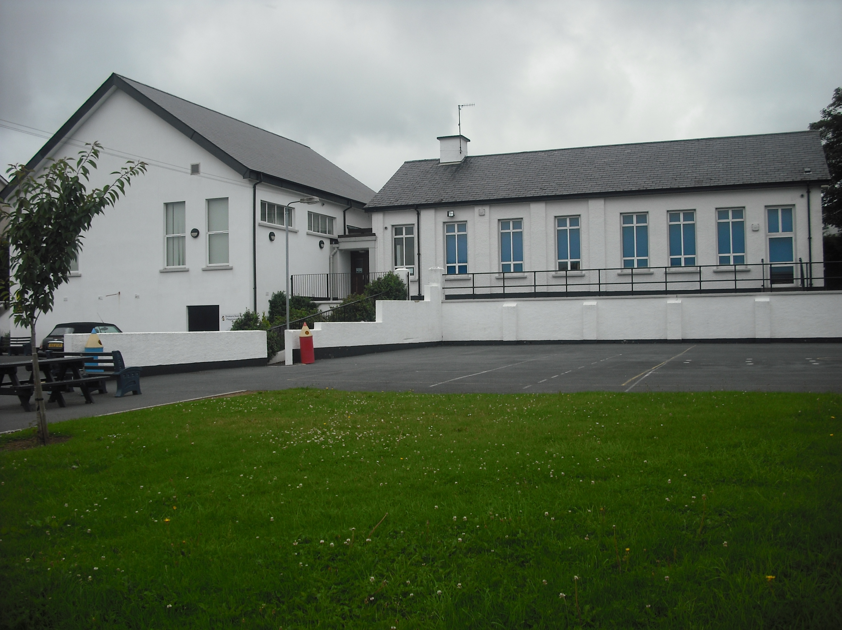
Dromore Road is a small controlled Primary school situated in the town of Warrenpoint. We provide education for children from P1 – P7.

RELATIONSHIPS AND SEXUALITY
POLICY
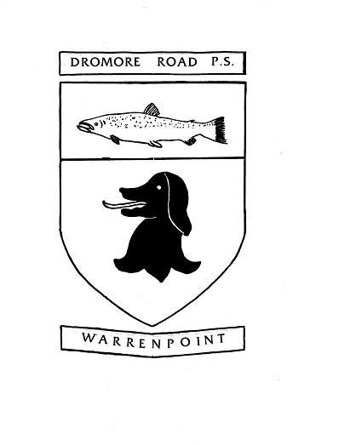

2017

RATIONALE

The Education (Northern Ireland) Order 2006 requires all grant aided schools to offer a curriculum which:
- Promotes the spiritual, emotional, moral, cultural, intellectual and physical development of pupils at the school and thereby of society; and
- Prepares such pupils for the opportunities, responsibilities and experiences of life by equipping them with the appropriate knowledge, understanding and skills

What is Relationships and Sexuality Education?

Definition
Relationships and Sexuality Education (RSE) is a lifelong process which encompasses the acquisition of knowledge, understanding and skills, and the development of attitudes, beliefs and values about personal and social relationships and gender issues. It is about helping children to build effective relationships and learn to value themselves and others, making well-informed decisions about their lives.

At Dromore Road Primary School we value the importance of Relationship and Sexuality Education to help and support young people through their physical, emotional and moral development. This policy is linked closely to Personal Development & Mutual Understanding (PDMU), The World Around US (WAU) and Religious Education (RE). The policy is also linked to the Relationships and Sexuality Education Guidance issued by CCEA.

Relationships education supports the curriculum aim which is ‘to empower young people to achieve their potential and to make informed and responsible decisions throughout their lives.’ The UN Convention on the Rights of the Child provides ‘all children with the right to express their views in matters affecting them.’

As part of the Relationship and Sexuality Education framework the following key areas underpinned the development of the Policy:
- Respect for the Rights of Children
- Promotion of understanding of Diversity, Inclusion and Mutual Understanding
- Safety in the Digital World
- Use of appropriate language and information
- Partnerships between school, home and the wider community
- Engagement with pupils
- Personal backgrounds / circumstances and cultural practices
- Sexual orientation and gender identity
- Teaching of sensitive issues
- Approaches to classroom relationships and methods of teaching and learning
- Resources e.g. Living, Learning Together; Helping Hands
- Responding to questions relating to Relationships and Sexuality Education
- Child Protection and Safeguarding
- Pastoral Care
- Pupils with Special Educational Needs
- Confidentiality / Disclosures
- Links to the Equality Act (sexual Orientation) Regulations (Northern Ireland) 2006.

Aims

The aims of RSE in Dromore Road Primary School are:

- To develop a loving pride in one’s family and to promote an appreciation of the importance of the family unit (regardless of structure/composition)
- To develop an active involvement in the local community
- To promote a warm, welcoming and positive learning environment
- To value all children as individuals and encourage them to achieve their highest personal, academic and social goals
- To foster the development of tolerance, respect and sensitivity
- To encourage pupils to examine and explore the various relationships in their lives and learn how to develop and enjoy friendships which are based on responsibility and mutual respect, within the school and at home
- To enhance the personal development, self-esteem and well-being of each child
- To provide pupils with the information and skills to evaluate critically the wide range of information, opinions, attitudes and values offered today
- To encourage pupils to avoid behaviours which could be harmful to themselves and /or others
- To educate children (and parents or carers) about the use of technology and the online world – safety, dangers and appropriate use
- To help children to identify potential risks to their safety and be aware of the strategies they can use to protect themselves
- To promote a shared vision of Relationships and Sexuality Education across the school
- To establish consistent standards and practices in delivering RSE.

RSE should:
- be relevant, accessible and age appropriate to all young people
- be set in a moral framework which is inclusive with respect to culture, religion, sexual orientation and social background
- seek to develop and clarify values and attitudes towards gender, sexuality and relationships and to encourage respect for and empathy with the values and attitudes of others
- respect the diversity of cultural identity and encourage pupils to be aware of the traditions and beliefs of others, promoting respect, mutual understanding and tolerance
- include activities to allow both genders to talk about their interests, attitudes, emotions, concerns and feelings.

Morals and Values Framework

Mindful of the Christian influence and the ethos which exists in Dromore Road Primary School and the diversity of religious and cultural groups in the school, pupils are taught RSE within a framework that encourages the following:

- A respect for self
- A respect for others
- Equal opportunities for all
- A sensitive and caring attitude towards the needs of others
- Development of personal skills which help to establish and sustain healthy personal relationships
- Commitment, trust and bonding within relationships
- An exploration of the rights, duties and responsibilities involved in relationships
- Honesty with self and others
- Self-discipline
- The difference between right and wrong
- The responsibility for one’s own actions
- A development of critical self-awareness for themselves and other.

Learning Outcomes

The RSE curriculum should enable pupils to develop:
• A sense of self awareness, self-esteem and self-worth
• An appreciation of the dignity, uniqueness and well-being of others
• Personal and inter-personal skills which help to establish and sustain healthy personal relationships
• An appropriate vocabulary to discuss feelings, gender/ sexuality, growth and development
• Awareness of the variety of ways in which individuals grow and change
• A critical understanding of external influences on lifestyles and decision making
• Communication skills – putting one’s own views forward clearly and appropriately; listening to others’ points of view; handling and resolving conflict peacefully
• Decision making and problem solving skills – for sensible and responsible choices; making moral judgements about what to do in actual situations
• Practical skills – for everyday living; for supporting others; for future parenting.

Confidentiality
The classroom is an open environment and confidentiality cannot be maintained. Therefore, staff and pupils are not encouraged to talk about their personal relationships or experiences during class discussions.
Teachers do not promise confidentiality during lessons.
Teachers can provide all pupils with information about where and from whom, they can receive advice and support.
Teachers encourage young people, where possible, to discuss their concerns with parents or guardians.
In line with Dromore Road’s Safeguarding and Child Protection Policy, teachers inform the Designated Teachers for Child Protection (Mrs English, Mrs K. Graham, Mrs McGrath) of any disclosures which might suggest that a pupil is at risk.

Areas of Responsibility:

Board of Governors
- To ensure the legal framework is followed
- To consult with parents on the determination of the school’s Relationships and Sexuality Education Policy
- To implement the Relationships and Sexuality Education Policy through the Principal
- To implement review cycles
- To ensure that parents have access to the Relationships and Sexuality Education Policy

Principal
- To implement the Relationships and Sexuality Education Policy
- To ensure the policy is followed by all staff
- To liaise with the Board of Governors on the teaching within the school
- To ensure the Policy is reviewed as deemed necessary by the Board of Governors
- To disseminate information to staff
- To respond to individual problems experienced by children – enlisting external agency support if necessary or appropriate.

Teacher
- Provide general educational advice to all pupils as part of the curriculum. This general advice can be given to pupils individually or within group situations
- Provide all pupils with information about where, and from whom, they can receive advice and support
- Any disclosure that might suggest a pupil is at risk is reported as outlined in the Safeguarding and Child Protection Policy

Outside Agencies e.g. school nurse, PSNI, NSPCC-childline, Helping Hands
- To support the Relationships and Sexuality Education Programme where appropriate
- To assist staff in the delivery and content of aspects of physical development (puberty), keeping safe (digital & sexual abuse) and aspects of Health Education
- Only appropriate medical professionals should give medical advice to pupils
- Outside Agencies supporting the delivery of the RSE programme should be aware of the school RSE policy.

The Special Needs Coordinator
- To assist in the development of the school’s policy concerning the welfare and educational needs of the children
- To identify children who may need to receive the RSE programme in a way suited specifically to their needs and ability of understanding and to assist teachers to adapt the programme to suit the needs of these children
- To identify children who may be ‘vulnerable’ for reasons of SEN, Sexual Orientation, home background, cultural or racial differences, prior to transfer to secondary level education.

How will we achieve our aims?

At home
As first educators, parents are expected to lay the foundations for all acceptable patterns of behaviour, leading by example, and sharing with school the joint task of bringing the child through primary school with a balanced understanding of life and a healthy appreciation of the human relationships they form in years to come.

At school
- The positive climate and constructive everyday interactions between pupils and staff, both inside and outside the classroom
- The messages we give out to children through religious celebrations, assemblies, discussions, workshops etc.
- The encouragement we give and the standards we uphold in terms of sportsmanship, fair play, accepting decisions and taking both winning and losing in the same spirit
- The respect we have for and show to all members of our community.

Staff
Staff should follow the established procedures –
- Staff should not enter into discussions about personal issues and lifestyle choices
- No-one (child or adult) should have to answer personal questions about their private lives
- When dealing with pupils’ questions of a sensitive nature the teacher should discuss the issue with parents/carers and/or a senior member of staff in order to discern an appropriate response
- Lessons will be delivered in both mixed-gender and single-gender (when appropriate) lessons
- No-one (child or adult) should be compelled to take part in a discussion which deals with sensitive issues
- Teachers should use the correct names and terms when dealing with the subject of physical changes and puberty
- Staff will not have pupils from school as ‘friends’ on any form of Social Media
- Concerns should be reported to The Designated Teacher for Child Protection / Safeguarding and / or the Principal immediately and children reassured.

Equal Opportunities
Generally RSE will be taught in mixed groups, so that boys and girls are encouraged to work with each other and gain an understanding of each other’s perspectives. However, there will be times that teachers or outside professionals will work with single gender groups, eg. P7 Love for Life programme, to explore puberty related physical and emotional changes in both boys and girls. The programme of RSE delivered will be accessible to all pupils regardless of age, culture, disability, sexual orientation, gender or social class.

Specific Issues

Child Sexual Abuse – Procedure
The Child Protection and Safeguarding Procedures as laid down by the Education Authority are followed and procedures are set out clearly in the school’s Child Protection and Safeguarding Policy.
Confidentiality should not prevent action being taken if the child is ‘at risk’. Teachers listen sympathetically to anything a child tells them in confidence; however, if a teacher believes that a child is at risk, the appropriate people will be contacted – in accordance with the above Child Protection and Safeguarding Policy and Procedures.

Child Withdrawal Procedure
Relationships and Sexuality Education at Dromore Road Primary School is taught across the curriculum and it is not possible to separate the lesson content. However, when Primary 7 receive the puberty information parents will be informed that the lesson is taking place and they will have the option to withdraw their child from this should they wish.

Procedures for the Involvement of Health Professionals and Visitors
Any Health Professionals and Visitors who are invited to deliver aspects of the curriculum will be required to provide an overview of the content and teaching methods, to the Principal and class teacher. A member of staff will remain in the lesson throughout.

Sensitive Issues
There will be no direct teaching of issues such as homosexuality, AIDS, contraception etc. However, if these issues are raised by pupils, the teachers will address them sensitively. RSE will include the physical and emotional changes that occur at puberty but will not include sex education.

Parents
Dromore Road Primary School seeks to work in partnership with parents through consultation and support. Pupils will be encouraged to appreciate the value of family life. Parents are vital in teaching children about relationships and sexuality, maintaining the culture and ethos of the family, helping children to cope with the emotional and physical aspects of growing and preparing them for the challenges and responsibilities that sexual maturity brings.
The school will support parents when necessary, in dealing with sensitive issues which may arise during their child’s primary school years.

Staff Training
Training needs will be considered and will be accessed when appropriate using the EA, Public Health Agency and/or other appropriate health agencies. Where outside agencies are used for training purposes, their remit will be clear and will reflect the ethos of the school.

This Policy is intrinsic to and supports the following Policies/areas:

Personal Development and Mutual Understanding
The World Around Us
Religious Education
Safeguarding and Child Protection
Pastoral Care
Positive Behaviour
Anti-Bullying
Drugs Education
Special Educational Needs
E-Safety & Acceptable Use of the Internet

Examples of events and activities to support the curriculum for the delivery of RSE
- Love for Life workshops
- NSPCC – childline assembly and workshop with P6/7
- Visitors to assembly – ministers, charity workers
- Class performances in assembly and other school performances
- Pupil of the week
- School Prize days
- EWO P7 visit –‘moving on’
- Visits to secondary schools
- School trips
- Internet safety workshop for teachers, parents and children – REIM solutions
- Anti-Bullying week – activities in each class and assembly
- Anti-Bullying Ambassador training
- First Aid – specific needs of individual children recognized
- Healthy Breaks
- P1 Induction
- School council and Eco council
- Inclusion and diversity – CEFR plans
- P6/7 fund raising enterprise
- Charity work – Cash for Clobber, Southern Area Hospice –Freddy Fitness, wear blue for Autism awareness
- Teacher Training – Helping Hands
- Parent Interviews – twice per year.

Useful References and Websites:-
www.saferinternet.org.uk www.thinkuknow.co.uk www.childnet.com/teachers-and-professionals www.kidsmart.org.uk
www.nspcc.org.uk www.safertoknow.info www.stonewall.org.uk www.exceedingexpectations.org.uk
www.endbullying.org.uk CCEA documents – www.ccea.org.uk

Evaluation, Reviewing and Monitoring

This policy has been written through consultation with parents/carers, pupils (through school council), staff and governors. Dromore Road Primary School recognises and accepts the importance of monitoring, reviewing and evaluating all aspects of Relationship and Sexuality Education at every level. To this end we follow the procedures for self evaluation as outlined in the DE document ‘Together Towards improvement.’

Signed: ________________
(Board of Governors)

________________
(Principal)

(Pastoral Care Coordinator)

Date: __________________

DROMORE ROAD PRIMARY SCHOOL RELATIONSHIPS AND SEXUALITY PROGRAMME
The following outline highlights the topics covered through the Northern Ireland Curriculum. All teachers will deliver the RSE programme, with many aspects included as part of PDMU, the World Around Us, PE, Drama and RE.
The sequences does not reflect exact teaching order of topics.

Foundation Stage & Key Stage 1:
Myself
- Myself, how I grow, feed, move and use my senses.
- Caring for myself – personal hygiene, sleep, exercise
- Naming basic parts of the body and developing an agreed
language for our body parts
- Being myself – I am unique, my self-esteem, self-confidence,
independence, respect and caring for myself
- Similarities and differences between myself and others e.g.
uniqueness, fingerprints, gender issues, different growth rates
- An introduction to the stages of human development –
changes as we grow e.g. baby -> child -> teenager -> adult -> mother / father -> grandparents
- Recognising moods, feelings and concerns and developing a
language and appropriate manner for expressing them e.g. what do I do if I feel sad? What do I do if I feel angry?
- Personal likes and dislikes.

My Relationships
- My family, special people in my life – what they do for me
and what I do for them
- Friendships – getting on with each other e.g. communicating,
playing together, listening, co-operating and sharing
- Ageing – how do we know that things are alive, dead, young or
old?
- Loss and Mourning (when appropriate) – death of a person or
pet (situations of individual children must be taken into account prior to dealing with this issue)
- Respect and caring for family members and friends e.g.
caring for a new baby
- Bullies and what to do about them
- Personal safety – simple skills and practices to maintain
personal safety
- Realise that adults and older children are not always friends and
the potential danger of relationships with strangers or acquaintances
- Strategies which pupils might use to protect themselves from
potentially dangerous situations.

My Community / Environment
- Awareness of different types of families
- Keeping safe e.g. dangerous places, dangerous situations, the adults
who will help, how to get help from others
- Rules at home, at school and in the community
- Respect and caring for people in the community e.g. elderly people,
disabled people

Key Stage 2
Myself
- My body and how it works
- How to keep my body healthy
- The physical, social and emotional changes which occur during
puberty (P7 girls and boys)
- Valuing and respecting myself, identifying personal strengths and
weaknesses
- Feelings e.g. things that make me happy, sad, excited, embarrassed,
angry, scared
- Expressing our feelings – showing love and affection
- Making Choices – the influences on me and the consequences of
action for oneself and others
- Distinguishing between right and wrong
- Secrets – knowing the difference between good and bad secrets.
What to do about bad secrets.

My Relationships
- Identifying the positive traits of friendship and their
corresponding values
- Differences and similarities in people; the need to respect the
other person’s point of view, emotions and feelings
- Families and how they behave. What family members expect of
each other
- The meaning of friendship and loyalty; making and maintaining
friendships and social relationships e.g. identifying and understanding pressures and influences, taking account of other people’s point of view
- Handling difficult situations e.g. teasing, bullying, death of a family
member
- Behaviour – what constitutes appropriate and non-appropriate
physical contact
- Identifying dangers and risks within relationships
- Being assertive in defending individual rights and beliefs
- People who can help children with their anxieties, concerns or
questions.

My Community / Environment
- Appreciation of the family in relation to the school and wider
community
- Cultural differences in families and family relationships, when appropriate
- Using agencies which can support families and individuals in
different circumstances, when needed
- Messages about health, gender roles and sexuality from the media,
internet, family and peers when they arise.

