Dromore Road Primary School

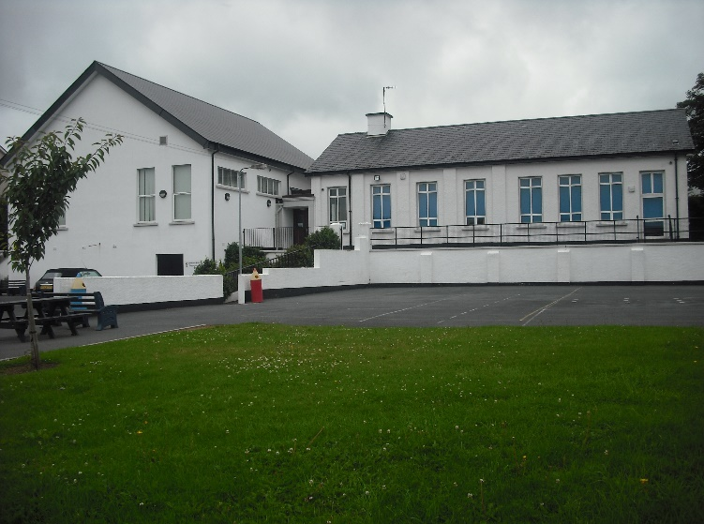
Dromore Road is a small controlled Primary school situated in the town of Warrenpoint. We provide a broad and balanced education for children from P1 – P7.

I.C.T
POLICY

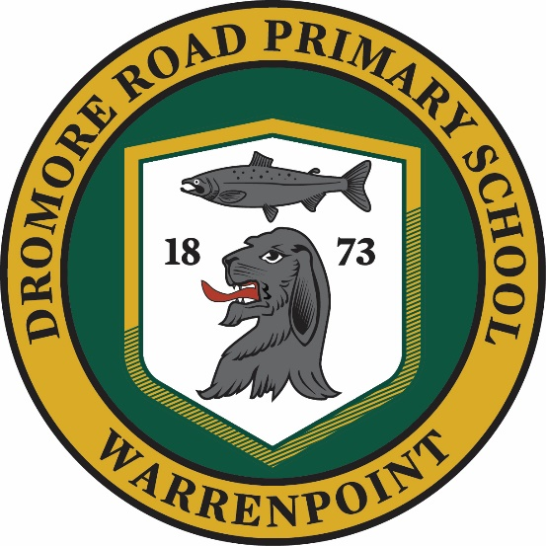

Contents

Introduction Page 3

Rationale Page 3

Aims Page 4

Strategies Page 4

Requirements for Using I.C.T. Page 5

ICT Competences Page 7

Planning and Progression Page 7

Monitoring Page 8

Assessment, Recording and Reporting Page 8

Evaluating Page 9

Inclusion and Equal Opportunities Page 9

Access and Resource provision Page 9

Roles and Responsibilities Page 11

Using ICT to support Home Learning Page 12

Policy Review Page 12

Introduction

At Dromore Road Primary School we understand that ICT plays a huge part in the lives of the pupils, staff, parents, governors and the community in general. We recognise the importance of Information and Communication Technology (ICT) in the primary school curriculum for preparing pupils to participate in a rapidly changing world in which work and other activities are constantly being transformed by access to varied and developing technology. ICT is an important tool in both the society we live in and the teaching and learning process. Our vision is for all members of the school community, both students and staff, to become confident users of ICT so that they can develop the skills, knowledge and understanding which enables them to use appropriate ICT resources effectively as powerful tools for teaching and learning.

Rationale

At Dromore Road Primary School, we believe;

- ICT provides opportunities to enhance and enrich the learning process across all areas of the curriculum.
- ICT can improve the thinking skills and personal capabilities of pupils.
- ICT can motivate and enthuse pupils as the learning style is unique.
- ICT allows children to explore, manage and evaluate information.
- ICT promotes independent learning.
- ICT offers potential for effective group work and collaborative learning.
- ICT has the flexibility to support different learning styles i.e. audio, visual and kinesthetic.
- ICT gives opportunities for the development of pupils’ creativity.
- ICT encourages learners in research based, flexible and effective forms of learning that will contribute to lifelong learning.
- In today’s society, pupils need to develop ICT skills in order to access relevant information.

Aims

We aim:

- To raise levels of pupil competence and confidence in using ICT - by developing children’s knowledge, understanding and skills in using a range of ICT tools to enhance learning experiences across the curriculum
- To raise levels of teacher competence and confidence in integrating ICT into their planning, teaching and assessment of children’s work (using ICT as an integral part of the processes and the management of teaching and learning)
- To use ICT to enhance and enrich children’s learning and add to its enjoyment
- To provide access to electronic sources of information and interactive learning resources
- To enable children and teachers to have access to immediate and up-to-date sources of information
- To develop children’s independent learning skills using ICT across the curriculum
- To develop information handling and research skills.

Strategies for the use of ICT

- ICT is not taught as a distinct subject, but it is a tool to be used as appropriate throughout the curriculum
- All pupils are given equal access
- ICT is an entitlement for all pupils
- Common tasks are set that are open-ended and can have a variety of responses
- We provide suitable learning opportunities for all children by matching the challenge of the task to the ability and experience of the child
- Use of ICT at home will continue to be encouraged through meaningful projects, homework and the use of programmes such as Mathletics and Reading Eggs.
- Children should continue to be encouraged to access and make use of the school website which is regularly update- www.dromoreroadps.com.

Requirements for Using ICT in the Northern Ireland Curriculum

Using ICT is identified as one of the three key cross curricular skills in the Northern Ireland Curriculum (CCEA, 2007). Children will be given the opportunity to develop skills in ICT in accordance with the Northern Ireland Curriculum guidelines which state:

Information and Communications Technology across the curriculum has the potential to transform and enrich pupils’ learning experiences and environments. It can empower pupils, develop self-esteem and promote positive attitudes to learning. Additionally, the creative use of ICT has the potential to improve pupils’ thinking skills, providing them with opportunities to become independent, self-motivated and flexible learners.

Pupils should develop the skills of Using ICT by engaging in meaningful research and purposeful activities set in relevant contexts. They should use ICT to handle and communicate information, solve problems, pose questions and take risks. They should process, present and exchange their ideas and translate their thinking into creative outcomes that show an awareness of audience and purpose. They should also use ICT to collaborate within and beyond the classroom, to share and exchange their work and to exhibit and showcase their learning.
(CCEA, 2007).

At Dromore Road Primary School a clear line of progression exists across the key stages within the school to ensure that pupils, at a level appropriate to their ability, are enabled to develop these five core skills of Explore, Express, Exchange, Evaluate and Exhibit.

Explore
Pupils should be enabled to:
- access and manage data and information;
- research, select, process and interpret information;
- investigate, make predictions and solve problems through interaction with digital tools;

Express
Pupils should be enabled to:
- create, develop, present and publish ideas and information using a range of digital media;
- create information and multimedia products using a range of assets.

Exchange
Pupils should be enabled to:
- communicate using a range of contemporary methods and tools;
- share, collaborate, exchange and develop ideas digitally.

Evaluate
Pupils should be enabled to:
- talk about, review and make improvements to work, reflecting on the process and outcome;
- consider the sources and resources used.

Exhibit
Pupils should be enabled to:
- manage and present their stored work;
- showcase their learning across the curriculum.

Throughout all of this work children should understand how to keep safe and display acceptable online behaviour.

Desirable Features

It is our aim to give our pupils a broad and balanced experience of using ICT, as such, we endeavor to enable our pupils to develop their skills in using the 5Es across all of the desirable features identified by CCEA throughout their primary education. These desirable features are;

- Computational Thinking and Coding
- Digital Art and Design
- Digital Audio
- Digital Storytelling: Film and Animation
- Digital Storytelling: Presenting
- Digital Storytelling: Publishing
- Managing Data.

ICT Competences

At Dromore Road Primary School we endeavor to help our pupils to develop competence in the use of ICT. This involves;

- Learning about ICT- developing the knowledge and skills required to use ICT effectively and to apply these in a range of contexts.

- Learning through ICT- developing the skills required to access and use information from a range of electronic sources, interpret it and use it effectively.

- Learning with ICT- applying the skills in their own learning either at school, at home or in the community.

Planning and Progression

All children develop and learn at their own pace. Planning for ICT ensures coverage of the statutory requirements for ICT as set out under the five ‘E’s’- Explore, Express, Exchange, Evaluate and Exhibit. All pupils have opportunities to develop a wide range of skills and competencies, in line with their age and abilities as the progress through the school.

A Line of development in ICT ensuring progression and continuity for children in each year group has been drawn up and agreed by all staff. Planning is embedded into long, medium and short term teacher planning.

Monitoring

Monitoring ICT will enable the Co-ordinator to gain an overview of ICT teaching and learning throughout the school. The ICT Co-ordinator will monitor planning for ICT and assist class teachers appropriately.

Evidence in the form of children’s work, is stored within each pupil’s folder on the shared resources files of the school system. Teachers will assess pupils’ abilities in the use of ICT in line with the Levels of Progression and these will be reported to the ICT Co-ordinator. Internal moderation of levels assigned and samples of pupils’ work will take place, led by the ICT Co-ordinator as appropriate.

It is the responsibility of the ICT Co-ordinator to monitor the standard and progress made within ICT by gathering appropriate evidence during each school year. Statutory end of Key Stage results for Using ICT are monitored by the school and reported to CCEA as appropriate.

Assessment, Recording and Reporting

ICT is assessed both formatively and summatively using the 5E’s as identified by the Northern Ireland Curriculum and the Levels of Progression laid out by CCEA. Throughout the year teachers will assess pupils’ skills and abilities, tracking these each term, and using this information as a basis for an end of year level which is recorded in the pupil profiles and passed onto the next teacher. Formative assessment occurs on a lesson by lesson basis based on the learning intentions of the lesson. These are conducted informally by the class teacher and are used to inform future planning. Pupil work is stored centrally on the Shared Resources section of the school system, enabling each child to build a digital pupil profile. This enables internal moderation of levels to ensure consistency across the school and in line with the curriculum and internal moderation of samples of levelled work is carried out by the ICT Co-ordinator and where appropriate and possible, involves all the teaching staff. End of Key Stage assessment levels for ICT are recorded and submitted as required to the statutory agencies.

Teachers also keep samples of the children’s work in a school portfolio. This is stored on the Staff Documents section of the school system and helps to demonstrate the level of achievement in ICT throughout the school.

Teachers will report on a child’s progress to the next teacher by discussing progress, passing on samples of work and by passing on information regarding skill level.

Teachers will report on a child’s progress to parents/ guardians through informal discussion during parent meetings and through a formal comment regarding ‘Using ICT’ on the child’s annual report.

Evaluating

ICT provision and the attainment of pupils across the school is consistently monitored and evaluated. Appropriate amendments to planning are carried out, and activities tailored to meet the needs of individual learners and year groups, and to improve future teaching and learning. All staff are encouraged to be reflective practitioners of ICT. Skills audits are carried out by the ICT Co-ordinator amongst the staff to identify training needs to enable staff to best meet the needs of learners and to provide a broad and balanced classroom ICT experience.

Inclusion and Equal Opportunities

Our ICT facilities are available for use by all pupils and staff. All children are given access to ICT regardless of gender, race, physical or sensory disability. ICT can impact on the quality of work that children can produce and it can increase their confidence and motivation. Care will be taken to ensure that all pupils, including those with Special Educational Needs, have equal opportunities to be involved in ICT activities. The ICT Co-ordinator, in liaison with the SENCO, will endeavour to ensure appropriate adjustments are made including the requirement for specific resources. The school has in place extra resources such as colour coded keyboards and software such as Word shark, Number shark and Nessy fingers to help promote the inclusion of all pupils in ICT. We will endeavour to give opportunities to children who do not have access to ICT resources at home.

Access and Resource provision

Organisation of resources

ICT resources are deployed throughout the school to maximise access, to enhance teaching and learning and to assist in raising attainment. We are well resourced with networked laptops and workstations located in every classroom. All computers have access to printers. iPads are deployed throughout the school and assist with the integration of ICT into every day classroom activities. Promethean whiteboards are installed in all classrooms and a further portable interactive board, speaker and sound system is available for use throughout the building. A range of portable technology to supplement learning is also available. This includes headphones, microphones, Bluetooth keyboards, easispeak recorders, iPad pens, beebots and microbits.

Pupil access
Each child is enabled to access the computer systems using their own personalised login. Pupils are educated about the need to protect these important details from a young age. All computers and iPads have access to appropriate curriculum supporting programmes.

Teacher access
Adults within the school also have access to networked computers through their own login and iPads.

Both adults and children agree to school’s acceptable use policies as set out in the Online Safety and Acceptable Use of the Internet agreement in our Esafety Policy.

Roles and Responsibilities

The Principal
The overall responsibility for the use of ICT rests with the senior management of the school. The Principal, in consultation with the staff:

- determines the ways ICT should support, enrich and extend the curriculum;
- decides the provision and allocation of resources;
- decides ways in which developments can by assessed, and records maintained;
- ensures that ICT is used in a way to achieve the aims and objectives of the school;
- ensures that there is an ICT policy and identifies an ICT Co-ordinator.

ICT Co-ordinator
The appointed ICT Co-ordinator’s role is to oversee the planning and delivery of ICT across the school and to take a lead in promotion of Online Safety. The ICT Co-ordinator will be responsible for:

- providing leadership and direction;
- assisting all teachers with the implementation of this policy;
- facilitating the use of ICT across the curriculum in collaboration with all subject Co-ordinators;
- providing and organising training to keep staff skills and knowledge up to date;
- advising colleagues about effective teaching strategies, managing equipment and purchasing resources;
- monitoring and evaluating the delivery of the ICT curriculum and reporting to the Board of Governors, through the principal, on the effectiveness of provision.
- Updating the ICT policy, action plans and internet guidelines and informing staff of these documents.

Classroom Teachers

It remains the responsibility of each teacher to;

- contribute to whole school planning for ICT;
- integrate ICT into curriculum planning, classroom teaching and the assessment of children’s work;
- ensure that any ICT resource/ software used in the classroom is appropriate to curriculum needs and children’s learning needs;
- ensure health and safety practices are carried out;
- implement the E Safety Policy.

Using ICT to support Home Learning

We are committed to exploring new and innovative digital tools to support both pupils and their parents/ guardians at home. Staff seek new opportunities to reinforce learning across the curriculum at home. This has been particularly relevant since the onset of the Covid 19 Pandemic in 2020. The use of websites and online learning tools such as Seesaw, Mathletics and Reading Eggs used in school aims to support parents in developing the children’s learning at home in a real and meaningful way.

Policy Review
Given the ever changing nature of technology and development, this policy will be reviewed every two years by the ICT Co-ordinator.

Signed:
Chairperson |  | Date:
Principal |  | Date:
Co-ordinator |  | Date:

