Dromore Road Primary School

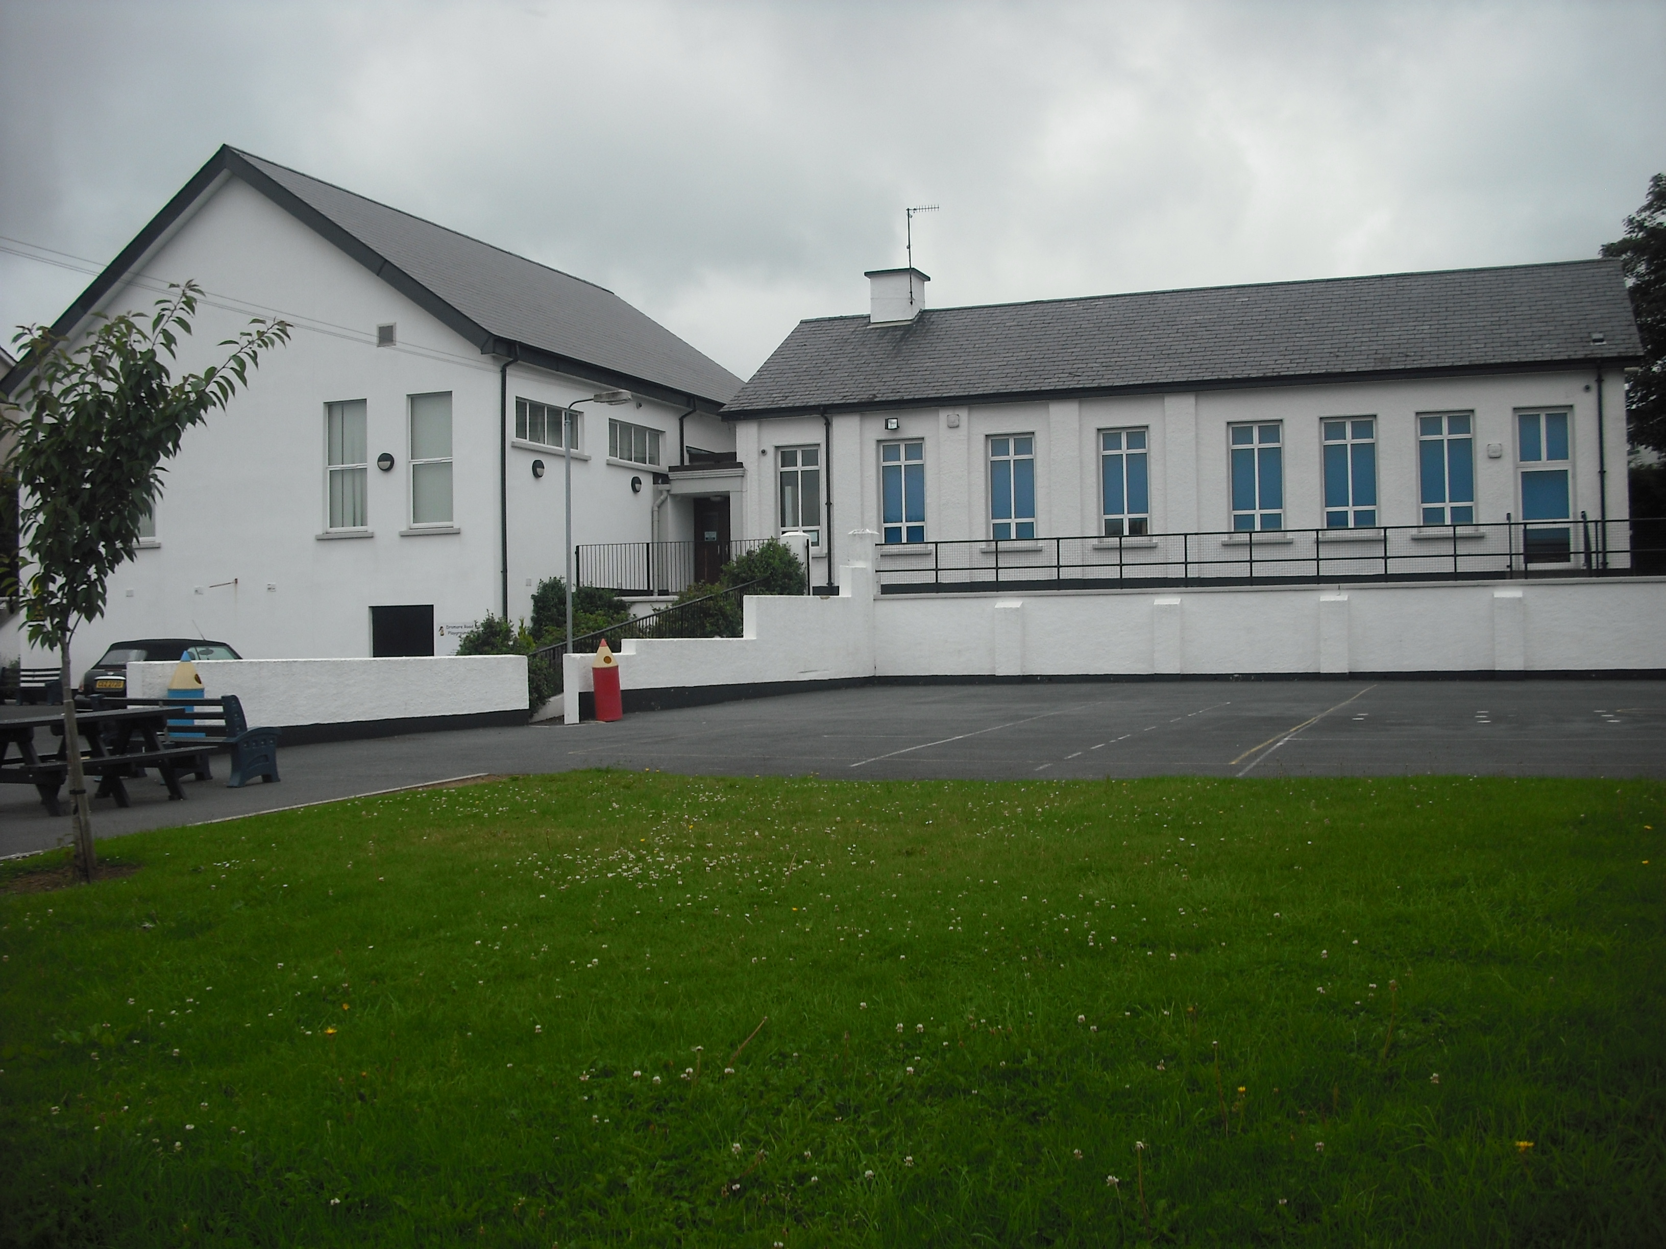
Dromore Road is a small controlled Primary school situated in the town of Warrenpoint. We provide education for children from P1 – P7 and have a current enrolment of 93 pupils.

MEDICATION POLICY


2018/19

ADMINISTRATION OF MEDICATION IN SCHOOL POLICY

The Department of Education issued advice to school for Supporting Pupils with Medication Needs (2008). This document acknowledges that there is no legal duty that requires school staff to administer medication; this is a voluntary role.

As an inclusive school, Dromore Road Primary School recognises children with special educational needs, disabilities or medical needs will be educated in our school. This may include children with complex medical needs, where a number of specific procedures may be required in relation to their physical health. This policy has been written to manage medication in schools and, where teachers or other staff have shown willingness to assist in the administration of medication, to help put in place effective management systems to support individual pupils with medical needs.

The Board of Governors and staff of Dromore Road Primary School has considered Medication Needs based on three categories:

1.Pupils requiring short term prescribed medication for acute conditions, for example an ear or chest infection. Usually such children will have been off school, but may still be on medication when they return. No short-term prescribed medication will be administered to any child by the staff at Dromore Road Primary School. Arrangements can be made for parents to come to school and administer any medication deemed necessary to their child.

Please note that parents should keep their children at home if acutely unwell or infectious.

2. Pupils with a long-term condition requiring regular medication; the two biggest categories within this group would be children with asthma and those with ADHD.

3. Pupils who may very rarely require medication to be given in an emergency: Two different types of medical emergency may arise within the school setting:

• Where the pupil has not previously been known to have a medical condition and the medical emergency arises “out of the blue”.
• Where a pupil with a known medical condition and a Medication Plan experiences a medical emergency in the context of their condition, such as children with severe allergies who may need an adrenaline injection.

The Board of Governors and staff of Dromore Road Primary School wish to ensure that pupils with long term medication needs or who may need medication in an emergency receive appropriate care and support at school. The Principal will accept responsibility in principle for members of the school staff giving or supervising pupils taking prescribed medication during the school day where those members of staff have volunteered to do so.

Parents are responsible for providing the Principal with comprehensive information regarding the pupil’s condition and medication.

Prescribed medication will not be accepted in school without complete written and signed instructions from the parent.

Staff will not give a non-prescribed medicine to a child unless there is specific prior written permission from the parents.

Only reasonable quantities of medication should be supplied to the school (for example, a maximum of four weeks supply at any one time).

Each item of medication must be delivered to the Principal or Authorised Person, in normal circumstances by the parent, in a secure and labelled container as originally dispensed.

Each item of medication must be clearly labelled with the following information:
-Pupil’s Name.
-Name of medication.
-Dosage.
-Frequency of administration.
-Date of dispensing.
-Storage requirements (if important).
-Expiry date.

The school will not accept items of medication in unlabelled containers.

Medication will be kept in a secure place, out of the reach of pupils. Unless otherwise indicated all medication to be administered in school will be kept in the staff room.

The school will keep records, which they will have available for parents.

If children refuse to take medicines, staff will not force them to do so, and will inform the parents of the refusal, as a matter of urgency, on the same day. If a refusal to take medicines results in an emergency, the school’s emergency procedures will be followed.

It is the responsibility of parents to notify the school in writing if the pupil’s need for medication has ceased.

It is the parents’ responsibility to renew the medication when supplies are running low and to ensure that the medication supplied is within its expiry date.

The school will not make changes to dosages on parental instructions.

School staff will not dispose of medicines. Medicines, which are in use and in date, should be collected by the parent at the end of each term. Date expired medicines or those no longer required for treatment will be returned immediately to the parent for transfer to a community pharmacist for safe disposal.

For each pupil with long term or complex medication needs, the Principal, will ensure that a Medication Plan and Protocol is drawn up, in conjunction with the appropriate health professionals. Staff who volunteer to assist in the administration of medication will receive appropriate training/guidance.

Where it is appropriate to do so, pupils will be encouraged to administer their own medication, if necessary under staff supervision.

Parents will be asked to confirm in writing if they wish their child to carry their medication with them in school. All pupils with Asthma are encouraged to keep a spare inhaler in their bag.

Staff who volunteer to assist in the administration of medication will receive appropriate training/guidance through arrangements made with the School Health Service.

The school will make every effort to continue the administration of medication to a pupil whilst on trips away from the school premises, even if additional arrangements might be required. However, there may be occasions when it may not be possible to include a pupil on a school trip if appropriate supervision cannot be guaranteed. Prescribed medication for the residential trip will not be accepted in school without complete written and signed instructions from the parent. A meeting must take place between the parents and the authorised teacher to discuss medication requirements.

All staff will be made aware of the procedures to be followed in the event of an emergency.

Signed by Principal:______________________________

Signed by Chairman of Board of Governors:___________________________

Date: _____________________

