Dromore Road Primary School

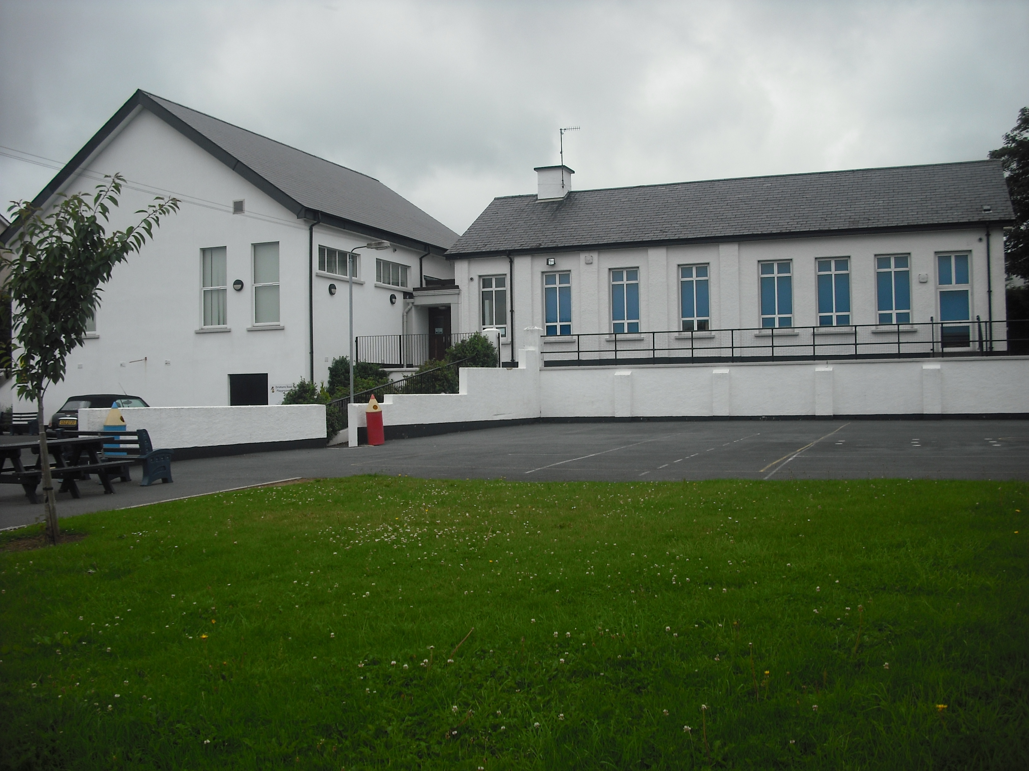
Dromore Road is a small controlled Primary school situated in the town of Warrenpoint. We provide a broad and balanced education for children from P1 – P7.

.

Policy for the Safe Use of Photographs/ Filming
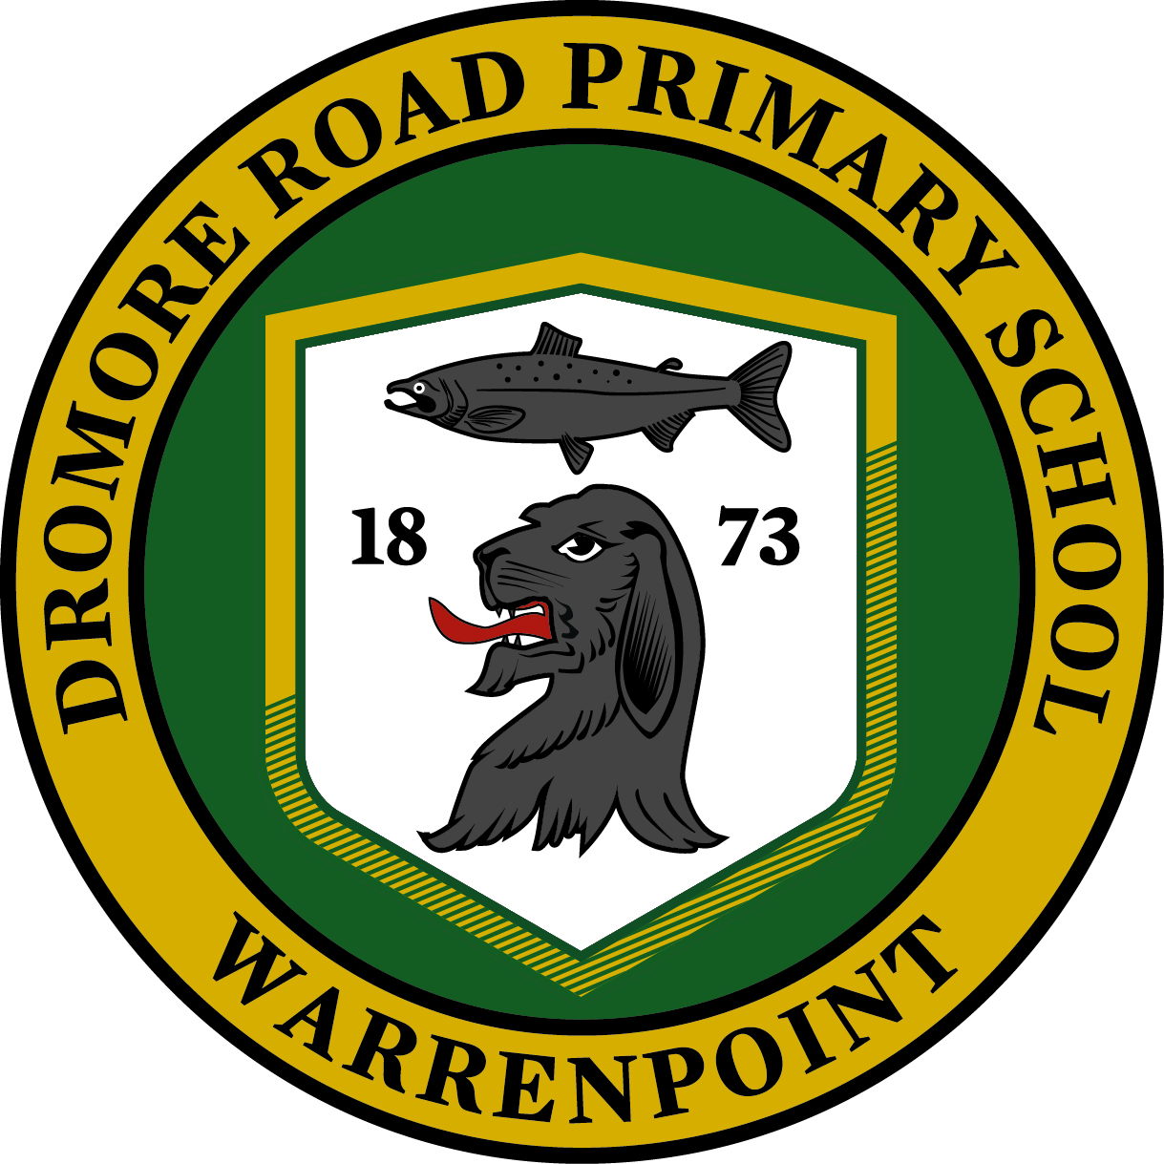

Introduction
Photographs and recordings of pupils for School, family and press are a source of pride to both the pupils and their families/legal guardians. Children’s photographs add colour, life and interest to school life and are invaluable in promoting school activities and initiatives.

Making use of photographs for publicity materials and to promote the school in the press can increase pupil motivation and staff morale, and help parents and the local community identify and celebrate the school’s achievements. However, photographs must be used in a responsible way. Schools need to respect children’s and parents’ rights of privacy and be aware of potential safe-guarding issues.

At Dromore Road Primary School every reasonable effort will be made to minimise risk by following the guidelines detailed in this document and by securing parental consent for the use of photographs. This policy applies to photographs, voice recordings or videos of children taken and used within school, within the school newsletter and publicity materials, on its website, in the press and for use on other community organisations’ websites and social media sites.

This policy reflects the consensus of opinion of the staff and governing body of Dromore Road Primary School. Its implementation is the responsibility of all staff. Parents and visitors will be made aware of this policy and a copy is displayed on the school website.

Child Protection
There may be a risk when individual pupils can be identified in photographs. For that reason, the governing body of Dromore Road Primary School have developed this policy to make every effort to minimise risk.

In the event of the inappropriate use of children’s photographs the Principal will inform the local Child Protection Services for Schools and / or the Police.

Data Protection
Taking, keeping and publishing photographs and video footage involves processing personal data under data protection laws. To enable us to comply with our obligations under the new General Data Protection Regulations (2018), we are required to obtain explicit consent to the use of a pupil’s image for example in school displays, performances, newsletters, prospectus and social media platforms.

Where photographs are taken at an event attended by large crowds, this is regarded as a public area so it is not necessary to get permission of everyone in a crowd shot. The Data Protection Act, 1998 does not apply to photographs or films taken for personal use by family and friends.

Appropriate Use of Images in School
The staff and governors of Dromore Road Primary School will:
-Ensure that images are stored securely and used only by those authorised to do so;
-Ensure that electronic images are stored on a secure network to which members of the public have no access;
-Not use an image of any child where child protection concerns have been made known to the school;
-Secure parental consent for the use of children’s photographs;
-Will have an appropriate retention period for the use of photographs of children who have left the school;
-Ensure that children are appropriately dressed.

School Website
The advice for using photographs on a website is no different from their use in any other kind of publication or publicity material. However, the staff and governors of Dromore Road Primary School are aware of the potential risk of inappropriate use of images because of the lack of control over who might see the image and the wide extent of the misuse of the internet. The governors will seek the consent of parents regarding the use of images on the internet.

To ensure the privacy and safety of pupils at the school, Dromore Road Primary School operates the following policy, regarding the use of photographs on its website:

1. Children’s names will not be included in photographs of individual children published on the school website.
2. Where an individual pupil is named, only their first name will be given and no photograph of that pupil will be displayed.
3. Where a photograph is used, which shows a group of pupils, only their first names may be used.

The Press
The use of photographs in newspapers and magazines is already subject to strict guidelines. There is no breach of the Data Protection Act, 1998 in passing on a child’s name to a journalist as long as parental consent has been secured.
Dromore Road will provide full names of children to accompany photographs published in newspapers and magazines only where the parent or guardian have provided their consent.

Photographing/ Filming Events
The photographing or filming of school events, e.g. sports day, arts performance, is a valuable part of school life and can be rewarding for both the family and the School. As previously detailed herein, there are no Data Protection issues, but the School will consider the ‘right to privacy’ as well as the actual manageability of photographing/filming such events. Thus, photographing and filming will be at the discretion of the Principal. Parents/carers should be aware that they are not permitted however to take photographs or to make a video recording for anything other than their own personal use. If the photographs or filming include others, they must not be put on social media platforms without their consent.

On occasions, commercial photographers visit the school. Where a commercial photographer is used, the school will follow the NSPCC guidelines which are as follows:

-Schools should provide a clear brief about what is considered appropriate in terms of content and behaviour;
-Schools should issue the photographer with identification which must be worn at all times;
-Schools should let parents and children know that a photographer will be in attendance at an event and ensure they have received consent to both the taking and publication of films and photographs;
-Schools should not allow unsupervised access to children or one-to-one photo sessions.

If children or parents have any concerns about inappropriate or intrusive photography, they should report them to the Principal who would report them in the same manner as any other child protection concern.

Camera Phones in Schools
Concerns have been expressed about the risks posed directly and indirectly to children through the use of camera phones on school premises. In order to minimise risk at Dromore Road Primary Schools will:
- Staff will restrict the use of mobile phones to office areas, the staff room or areas away from the children, while school is in session

- Parents are asked not to photograph or film on school property (exception where the Principal has given permission to do so at an organised school event)

- Visitors will be advised of the restriction on the use of camera phones in school and, wherever possible, will be accompanied by a member of staff during the duration of the visit

- The school operates a no mobile phone policy for pupils. Children who bring a mobile phone on to the school premises will be asked to hand their phone in at the school office at the beginning of the school day and collect it at the end of the school day.

Parental Consent (Appendix 1)
The governors of Dromore Road Primary School will seek the consent of parents / guardians regarding the use of photographs of children when they join the school. The consent will be reviewed on an annual basis and include agreement on:

- How and where the photographs will be used .
-How long the school will use images.
-Details of how consent can be withdrawn.

Monitoring and Review
This policy and reviews of practices will take place on a biannual basis or if consent needs to be refreshed.
Chairman: Date:
Principal: Date:

APPENDIX 1
GDPR – Consent Form for Photographs/ Video

Consent Form for .............................................................. Year ...............................
Photographs and recordings of pupils for School, family and press are a source of pride to both the pupils and their families//legal guardians. Taking, keeping and publishing photographs and video footage involves processing personal data under data protection laws.
To enable us to comply with our obligations under the General Data Protection Regulation, we are required to obtain express consent to the use of a pupil’s image for example in school displays, performances, newsletters, prospectus and social media platforms.
In all instances below, the image or footage may be of an individual, small group, class or classes. Where pupils are named, we will use first names only unless we have sought prior permission from you to publish full names (*newspaper and media companies will often use a full name and we will not seek further permission for this). We will only use photographs and footage where pupils are appropriately dressed to reduce the risk of inappropriate use of the images or footage.
This consent form is valid for the academic year 2018 to 2019. It will be updated on an annual basis. Consent will also be refreshed where any changes to circumstances occur – this can include, but is not limited to, the following:
- New requirements for consent, e.g. an additional form of media to use with pupils/parents/legal guardians
- Changes to school circumstances, e.g. if a new Principal reviews how the school markets itself
I give permission for photographs, voice recordings or videos of my child to be taken and used within school, for example: displays in school entrance, achievement board etc | Yes/ No
I give permission for photographs of my child to be used in the printed school newsletter. I understand that it is posted in PDF format on the School website. | Yes/ No
My child may be named in the caption or article associated with the image in the school newsletter. | Yes/ No
I give permission for photographs, voice recordings or videos of my child to be used on the school's website. | Yes/ No
I give permission for my child’s work to be used on the school website. | Yes/ No
My child may be named in the associated captions or articles on the website. | Yes/ No
My child’s image, voice or work may be used in school promotional materials, for example: prospectus, other publications that we produce for promotional purposes. | Yes/ No
I give permission for media organisations to take photographs or video footage of my child and use them in local or national publications, on websites and on radio or television programmes. | Yes/ No
My child's name* may be used in connection with this material. (*In these instances full names are often used). | Yes/ No
Educational visits and links with other schools in the area form a big part of school life. Sometimes organisations e.g. St Bronagh’s, Warrenpoint Library etc. ask the school for permission to use photographs on their own websites or Facebook pages. I give permission for other organisations to use photographs of my child on their website and social media portals. Names will not be used. | Yes/ No
My child may feature in footage recorded for the purposes of teacher training which is shared with other teachers in the school or externally to help raise teaching standards. | Yes/ No
I give permission for photographs of my child to be taken and used within school to raise awareness of serious medical conditions with staff. | Yes/ No
I give permission for photographs of my child to be taken and used within school to raise awareness of special dietary requirements. This will be shared with the School Meals Service. | Yes/ No

- Please be aware that websites and social media can be viewed throughout the world and not just in the United Kingdom where UK law applies. The school currently has a website www.dromoreroadps.com and its associated app.
- We may continue to use your child's image or footage after they have left the School in promotional materials or on our social media or website accounts.
- We will not include personal e-mail or postal addresses, telephone or fax numbers on video, on our website or in any printed materials.
- We may include a pupil’s written work, projects and artwork including portraits of other pupils on our website and in promotional materials.

Consent can be withdrawn at any time by notifying the Principal and completing a new copy of this form. If you do not consent to a particular use of your child’s information, your child will not suffer any detrimental effect as a result.
Where you would like to amend the provisions for which consent has been provided, you must submit your request in writing to the Principal. A new form will be supplied to you to amend your consent accordingly and provide a signature.

Signed by parent/legal guardian ......................................................
Print name .........................................................
Relationship to child .......................................................................Date ............................

